
Dear Parents and Carers,
As we come to the end of a wonderfully busy and rewarding spring term, I would like to take a moment to celebrate all that has been achieved across our school community.
This term has truly reflected the unique spirit of Meadow View Farm School. From hands-on learning in our farm, forest and sensory garden to enriching trips and experiences, our pupils have continued to demonstrate resilience, curiosity and a growing sense of responsibility. It has been a pleasure to see the children so engaged in their learning—whether planting trees and building habitats, caring for animals, or exploring new skills through outdoor and creative activities.
We are incredibly proud of the way our pupils have embraced opportunities beyond the classroom. Highlights such as the visit to Warwick Castle brought learning to life, with pupils showing fantastic behaviour and enthusiasm throughout the day. These experiences are invaluable in helping our children build confidence and develop a love of learning.
Our school community has also continued to show remarkable generosity and teamwork. Raising over £10,000 for LOROS is an outstanding achievement and something everyone involved should feel very proud of.
I would also like to extend a warm welcome to the new members of our team, who have already made a positive impact, and to thank all of our staff for their continued dedication and care.
Finally, thank you to all of our families for your ongoing support. I wish you all a restful and enjoyable Easter break, and we look forward to welcoming the children back for another exciting term.
Katie

Trips, Physical Activity and Well-being
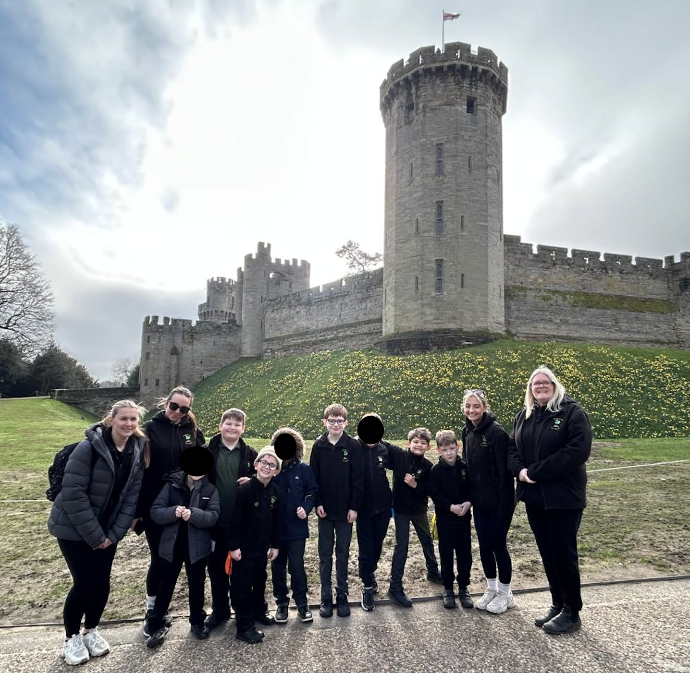
Class 2 had a fantastic day stepping back in time during their visit to Warwick Castle. The children explored the impressive grounds, climbed the towers, and discovered what life was like in a real medieval castle. The pupils were wonderfully behaved throughout the day and showed great curiosity, asking thoughtful questions and sharing their knowledge. It was a memorable experience for everyone and a brilliant way to bring our history learning to life.
Looking ahead to the summer term:
- Class 1 will continue to swim each Wednesday.
- Class 2 will start Tennis sessions each Thursday
- Class 3 will visit Sport in Desford (SiD) on a Monday
- Class 4 will start Horse Riding each Friday
- Class 5 will start swimming each Thursday

Newsletter Spring Term 2026

Dates for the Autumn Term 2025/26
Summer Term
- Monday 13th April – First day back after Easter
- Monday 4th May – school closed for bank holiday
- Friday 22nd May– last day of Summer 1
- Monday 25th May – Friday 29th May – half term break
- Monday 1st June – First day back after half term
- Tuesday 14th July - Last day of the school year (12:30 finish)
Other dates for your diary:
- Thursday 4th June – Year 6 residential
- Friday 26th June – Zones of Regulation Parent Workshop
- Friday 10th July – Year 6 Leavers’ Assembly
The term dates for 2026/27 have been finalised and are on the school website.

World Book Day


