Have a lovely Easter break and we will see you all on Monday 13th April 2026
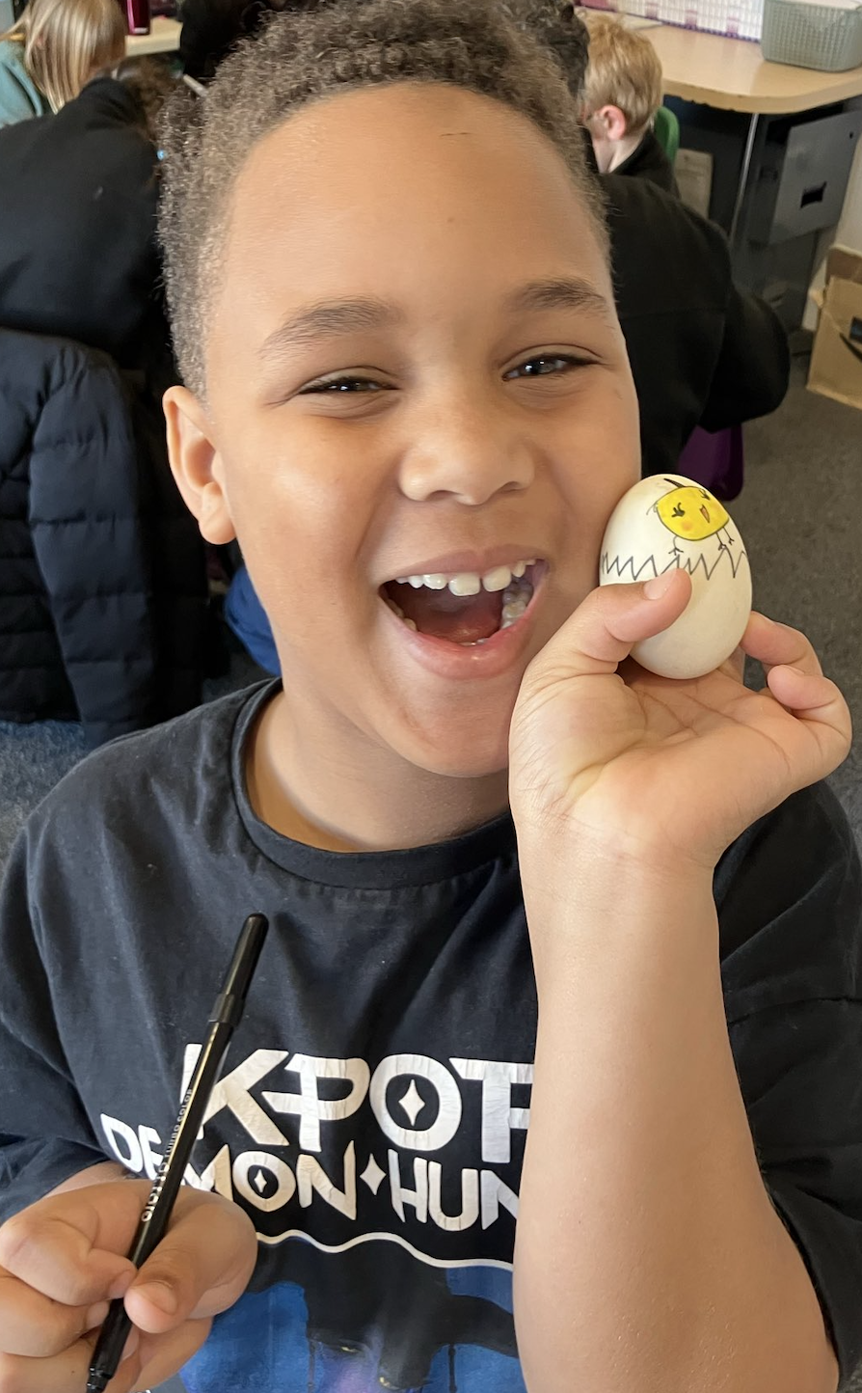

Staffing

We are pleased to welcome Ramona, our new Teaching Assistant, who has already settled in brilliantly and become a valued member of the team. We are also looking forward to Claire, our new Family Support Worker, who has already spent some time in school getting to know us and will officially begin her role after the Easter break.



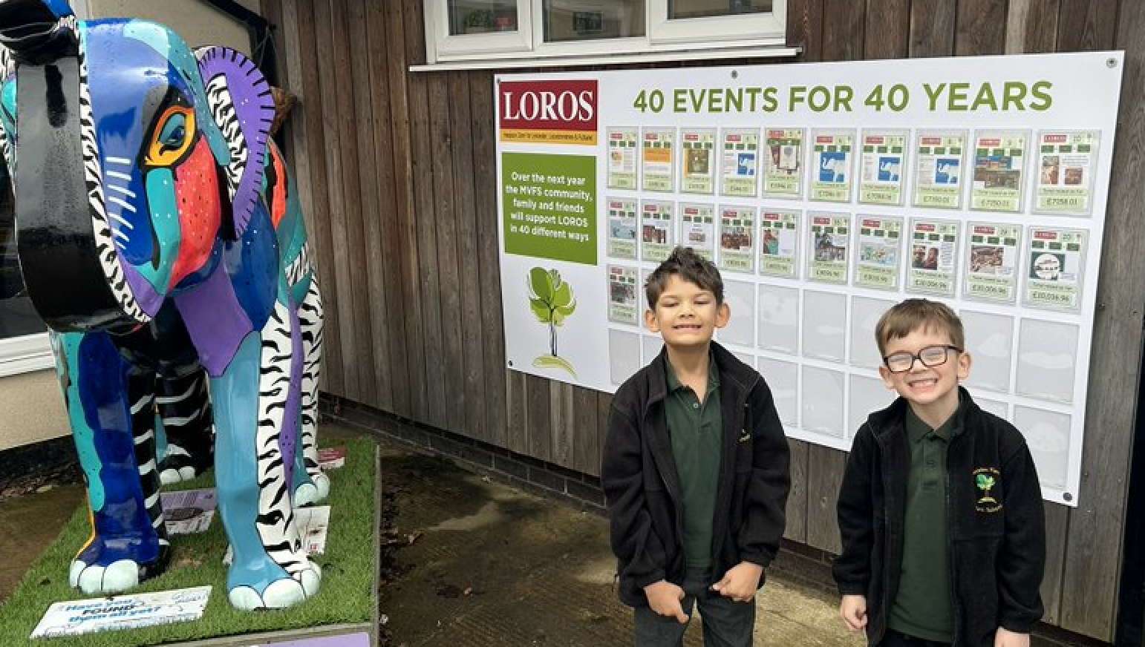We are incredibly proud to share that our LOROS fundraising efforts continue to go from strength to strength. Having now completed 23 events, our school community has raised an amazing total of over £10,000! This is a fantastic achievement and a testament to the enthusiasm, generosity and commitment of our pupils, staff and families. From sponsored events to community activities, every contribution has made a real difference. Thank you to everyone who has supported us so far—we look forward to continuing our fundraising journey and making an even greater impact.
Farm, Forest & Outdoor Adventures in the Secret Garden
This spring term has been full of exciting developments in both the forest and the farm. In the forest, our focus on trees has supported an ongoing project to develop the nature island, where the children have been busy planting trees, creating a new hedgerow habitat, and working together to clear and improve the area. A highlight has been the planting of a beautiful willow dome, as well as building a bridge to access the island more easily. The children also enjoyed celebrating with an Easter egg hunt and even had the chance to cook pancakes outdoors. On the farm, there have been many memorable moments too. Our ducks laid eggs for the first time, which was very exciting, and we welcomed new lambs, learning about tagging and tail docking. We said a sad goodbye to Dawny and also saw our pigs head off to the butchers, helping the children understand the full farming cycle. After Easter, we look forward to welcoming new pigs and continuing our hands-on learning experiences.
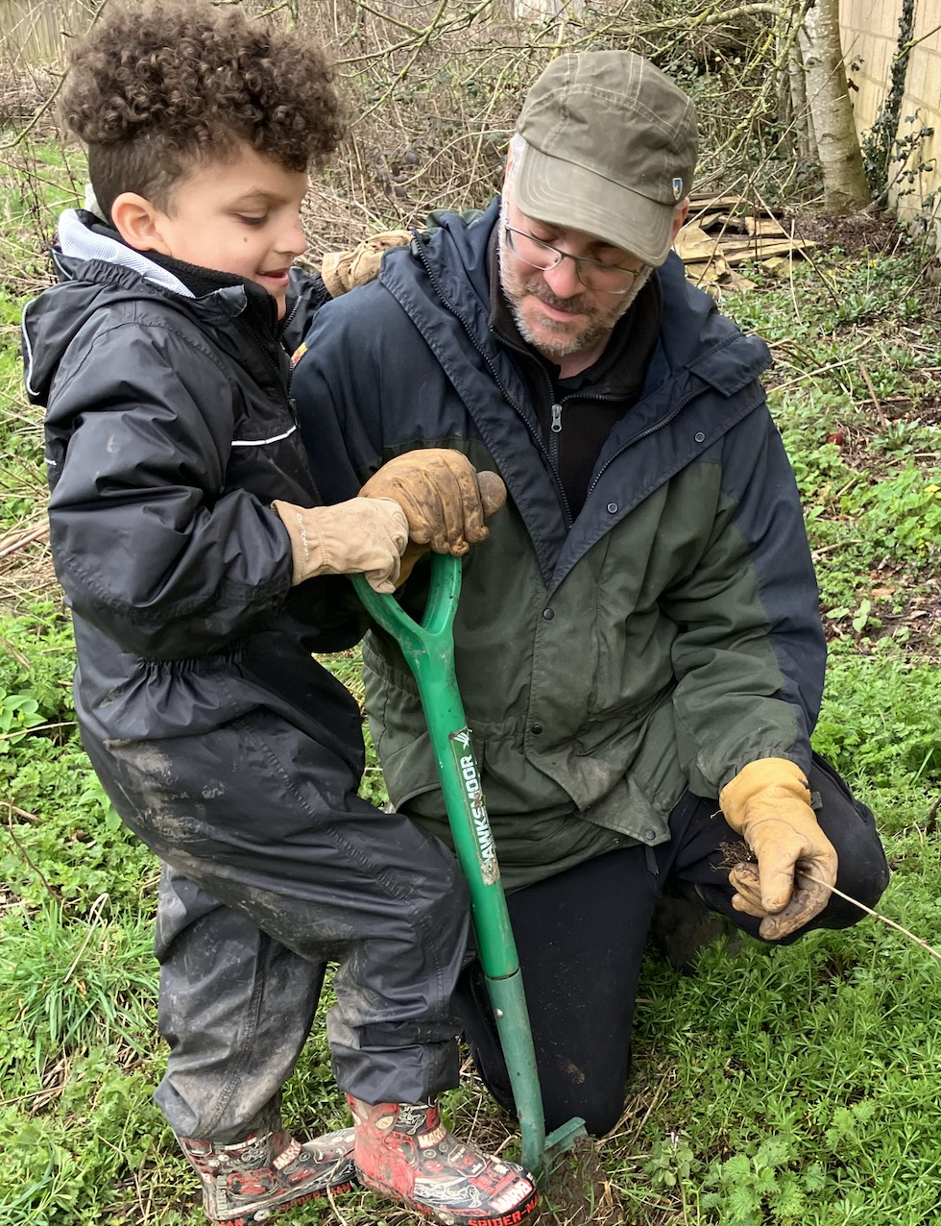
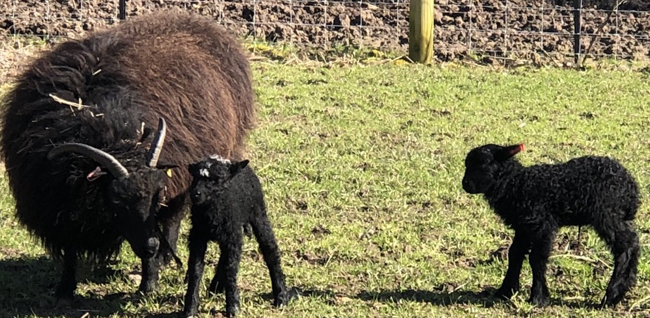
In the Secret/Sensory Garden it has been full of hands-on learning and seasonal activities. The children have explored the natural world through planting Mother’s Day flowers, sowing a wide range of spring and summer seeds, and growing vegetables including beans, onions, lettuce and potatoes. They have enjoyed cooking their own campfire meals, celebrating Pancake Day, and taking part in Garden Club activities linked to signs of spring. Creative learning has included making story stones, seed bombs, and even building wormeries, alongside investigating floating and sinking through water play.


