

Safeguarding Policy
In accordance with: Keeping Children Safe in Education 2026 & Working Together to Safeguard Children 2026

Policy statement

The school’s safeguarding arrangements are inspected by Ofsted under the judgements for leadership & management and also impact the judgement on the personal development, behaviour and welfare of children and learners.

This policy is available on the school website and all staff and volunteers are required to read it and confirm in writing they have read and understood it before commencing work in school.

This policy will be reviewed at least annually unless an incident, new legislation or guidance suggests the need for an interim review. Representatives of the whole school community of pupils, parents, staff, volunteers, and governors will be involved in reviewing, shaping, and developing the school’s safeguarding arrangements and child protection policy.

This policy will reference online abuse and abuse that will take place in person, please be aware that they are not mutually exclusive, and children can experience these types of abuse simultaneously.

Headteacher - This refers to the senior leader or manager who retains accountability for all safeguarding-related matters within the school or college.

Meadow View Farm School
Child protection and safeguarding policy
Date of publication: September 1st 2026 Review date: September 1st 2027

Reviewed by:

Designated Safeguarding Lead ..........Katie Simpson...........Date: .....03.08.2026..........

Deputy Designated Safeguarding Lead/s ..Ben Long, Ryan Kilby ...Date: ...................................................

Headteacher ....Katie Simpson.......Date: ....03.08.2026

Nominated Director: …Ryan Kilby………
Date: .……………………………………………….

Academies, free schools, independent schools, alternative providers of education - Section 157 of the Education Act 2002 and the Education (Independent School Standards) Regulations 2014, 2021 require proprietors of independent schools (including academies and city technology colleges) to have arrangements to safeguard and promote the welfare of children who are pupils at the school.

Table of Contents
Child protection and safeguarding policy | 1 page
1. Policy statement  - Policy Aims  - Policy Principles | 4
2. Safeguarding Legislation and guidance  - Making a Safeguarding referral for Children | 6  7
3. Safeguarding information for all staff | 10
4. Responsibilities to implement policy | 11
5. Recognising and responding to abuse | 16
6. Responding to safeguarding issues | 18
7. Sexual Violence, Sexual Harassment in school | 22
8. Children with increased risk factors | 25
9. Recognising abuse – training | 27
10. Recruitment | 28
11. Supervision | 28
12. Safer Working Practice | 29
13. Single Central Record | 30
14. Confidentiality and Consent | 30
15. Records and transferring files | 31
16. School Lettings | 32
Appendix 1 Terminology | 33
Appendix 2 Low Levels Concern Policy | 34
Appendix 3 Policy for the use of Mobile Phones and Wearable Devices | 37
Appendix 4 Safeguarding children who are vulnerable to extremism and radicalisation | 38
Appendix 5 Prevent Risk Assessment | 39

- The aim of the policy is to:
To provide all staff with the necessary information and standards to enable them to meet their safeguarding and child protection responsibilities.
To effectively apply consistent good practice, through training, auditing, and development.
To demonstrate the school’s commitment with regard to safeguarding and child protection to pupils, parents, and other partners.
To contribute to the school’s safeguarding portfolio.

1.2 School will therefore ensure the following arrangements are in place to safeguard and promote the welfare of children.

Prevention: school will create an ethos and culture where all students feel secure and able to build trusted relationships with staff. Children will be encouraged to talk and feel confident that they will be listened to. Staff and volunteers will be trained regularly to understand their responsibilities to recognise and report safeguarding or child protection concerns. This includes maintaining professional curiosity and understanding that children may not feel ready or know how to tell someone that they are being abused, exploited, or neglected and/or may not recognise their experiences as harmful. Students are taught about safeguarding, including online, through various teaching and learning opportunities as part of a broad and balanced curriculum.

Protection: school will ensure that each member of staff, governor and other visitor involved in regulated activity with students has undergone a thorough safer recruitment process and is sufficiently trained and supported to respond appropriately and sensitively to safeguarding and child protection concerns.

Support: Schools will provide structured systems of support for all students and appoint appropriately qualified and experienced staff (DSLs and DDSLs) to provide advice, training and support around safeguarding concerns.

Working with parents and external agencies: The school will work closely with parents to ensure appropriate communications and actions are undertaken. The school will develop and maintain links with relevant external agencies in all matters relating to safeguarding and child protection. All schools assess the risks and issues in the wider community as part of the safeguarding curriculum.

Commitment: schools expect everyone to share this commitment, creating a culture of vigilance.

1.3 School commits to acting in accordance with: Keeping Children Safe in Education. This policy does not aim to replicate the guidance in full. Therefore, the policy should be read in conjunction with at least Part One and Annex B of Keeping Children Safe in Education (2026); Working Together to Safeguard Children 2026; Working Together to Improve School Attendance; The Education (Independent School Standards) Regulations
1.4 Whilst the policy primarily focusses on the safeguarding of children, it also references the action to be taken if any member of the school community becomes concerned about the safety or welfare of an adult at risk, aged 18 or over.

Principles the policy is based on,
1.5 Meadow View Farm School recognises that:
• the safety and welfare of a student is always of paramount consideration and will work together with parents, carers and other agencies to safeguard and promote the welfare of the child;
• all children regardless of age, special needs or disability, racial or cultural heritage, religious belief, gender or sexual orientation have the right to be protected from ill treatment and neglect and to experience a good standard of care;
• all children have the right to be heard and that the wishes and feelings of the child should be sought and influence the decision making;
• all incidents and allegations of suspicious or poor practice or abuse will be taken seriously, listened to and responded to appropriately. This includes allegations raised through the whistleblowing procedures.
• there is a consistent understanding of acceptable behaviour of young people towards other young people and staff within the school and
• safeguarding is everyone’s responsibility.
1.6 School expects:
• Everyone to be alert to signs of abuse, neglect and exploitation and to follow procedures to ensure that children receive effective support, and protection;
• Everyone knows to whom they should report any concerns or suspicions;
• Everyone to be committed to creating a culture of safety that minimises the opportunity for any kind of abuse (including all forms of child-on-child abuse) through training, education and robust response procedures;
• School has procedures (of which all staff and visitors are aware) for handling suspected abuse of students, including procedures to be followed if a member of staff is accused of abuse, or suspected of abuse;
• A Designated Safeguarding Lead (DSL) and any Deputy Designated Safeguarding Leads (DDSLs) to have responsibility for co-ordinating action within the school and liaising with other agencies. They must develop expertise and skills to be the most appropriate person to advise on the response to safeguarding concerns.
1.7 School commits to work in partnership with our local authority Safeguarding Partnerships and will follow their guidance and implement their systems and protocols for referring families for early help and reporting child protection concerns. The school is committed to developing effective working practice with locality support networks and agencies. DSLs will ensure that all staff and the proprietary body are aware of issues and systems for reporting and will provide local safeguarding updates, as signposted by Warwickshire Safeguarding and partners;
1.8 This policy is applicable to all on- and off-site activities undertaken by pupils whilst they are the responsibility of the school;
1.9 Meadow View Farm School is committed to anti-discriminatory practice and recognises children’s diverse circumstances. Some children are at an increased risk of abuse, and additional barriers can exist for some children to recognising or disclosing abuse. We ensure that all children have the same protection, regardless of any barriers they may face.

2 Legislation and Statutory Guidance
2.1 Statutory Guidance
- Keeping Children Safe in Education (KCSIE) (2026)
- Working Together to Safeguard Children (2026)
- Working Together to Improve School Attendance (2024)
- Multi-agency statutory guidance on female genital mutilation (2020)
- Early Years Foundation Stage (2024)
- Teachers’ Standards July (2021)

2.2 Legislation
• The Children Act 1989 and The Children Act (2004)
• Section 5B (11) of the Female Genital Mutilation Act (2003), as inserted by section 74 of the Serious Crime Act (2015)
• The Rehabilitation of Offenders Act (1974)
• Safeguarding Vulnerable Groups Act (2006)
• Counterterrorism and Security Act (2015) (and the Prevent Duty guidance)
• The Education Act (2002)
• Education (Independent Academy Standards) (England) Regulations (2014)
• The Academy Staffing (England) Regulations (2009)
• Part 1 of the schedule to the Non-Maintained Special Academies (England) Regulations (2015)
• The Equality Act (2010)
• The Childcare (Disqualification) Regulations 2009 (and 2018 amendment)
• The Childcare (Act 2006)
• Public Sector Equality Duty (2012)
• Care Act (2014)
• Mental Capacity Act (2005)

2.3 The school has regard to the following guidance and reviews relating to safeguarding,
This policy has been devised in accordance with the following legislation and guidance:
- Working Together to Safeguard Children DfE (December 2026)
- Keeping Children Safe in Education DfE (2026)
- Working Together to Improve School Attendance, DfE (2024)
- Guidance for Safer Working Practices for Adults who work with Children and Young People in Education Settings (Feb 2022)
- What to do if you're worried a child is being abused DfE (March 2015)
- Information sharing: advice for practitioners providing safeguarding services DfE (May 2024)
- The Prevent duty: Departmental advice for schools and childcare providers DfE (September 2023)
- The Prevent duty: safeguarding learners vulnerable to radicalisation (September 2023)
- Mandatory Reporting of Female Genital Mutilation- procedural information Home Office (January 2020)
- Multi-agency practice principles for responding to child exploitation and extra-familial harm
- Child sexual exploitation: guide for practitioners DFE (February 2017)
- Teaching online safety in school DfE (January 2023)
- Mental Health and Behaviour in Schools DfE (November 2018)
- Data protection: toolkit for schools DfE (April 2024)
- Promoting the education of children with a social worker (March 2024)
- Preventing youth violence and gang involvement
- Criminal exploitation of children and vulnerable adults: county lines
- Relationships Education, Relationships and Sex Education (RSE) and Health Education
- Domestic Abuse Act 2021 Statutory Guidance (Home Office April 2023)

  - Guidance from the Local Authorities we have pupils residing in:

Warwickshire

www.safeguardingwarwickshire.co.uk

www.warwickshire.gov.uk/children-families/early-help-warwickshire/1
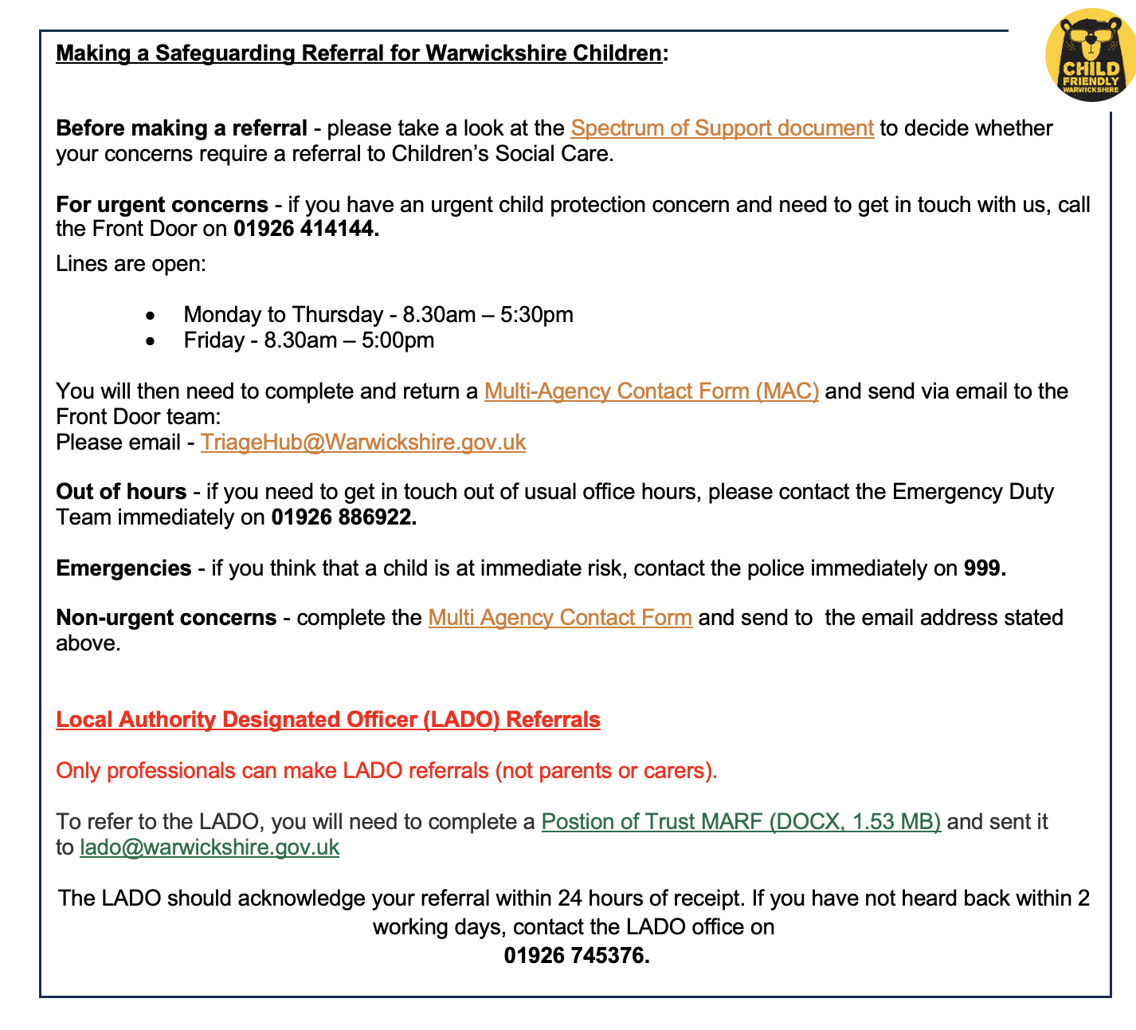

Leicestershire & Rutland Safeguarding Children Partnership:

https://lrsb.org.uk/

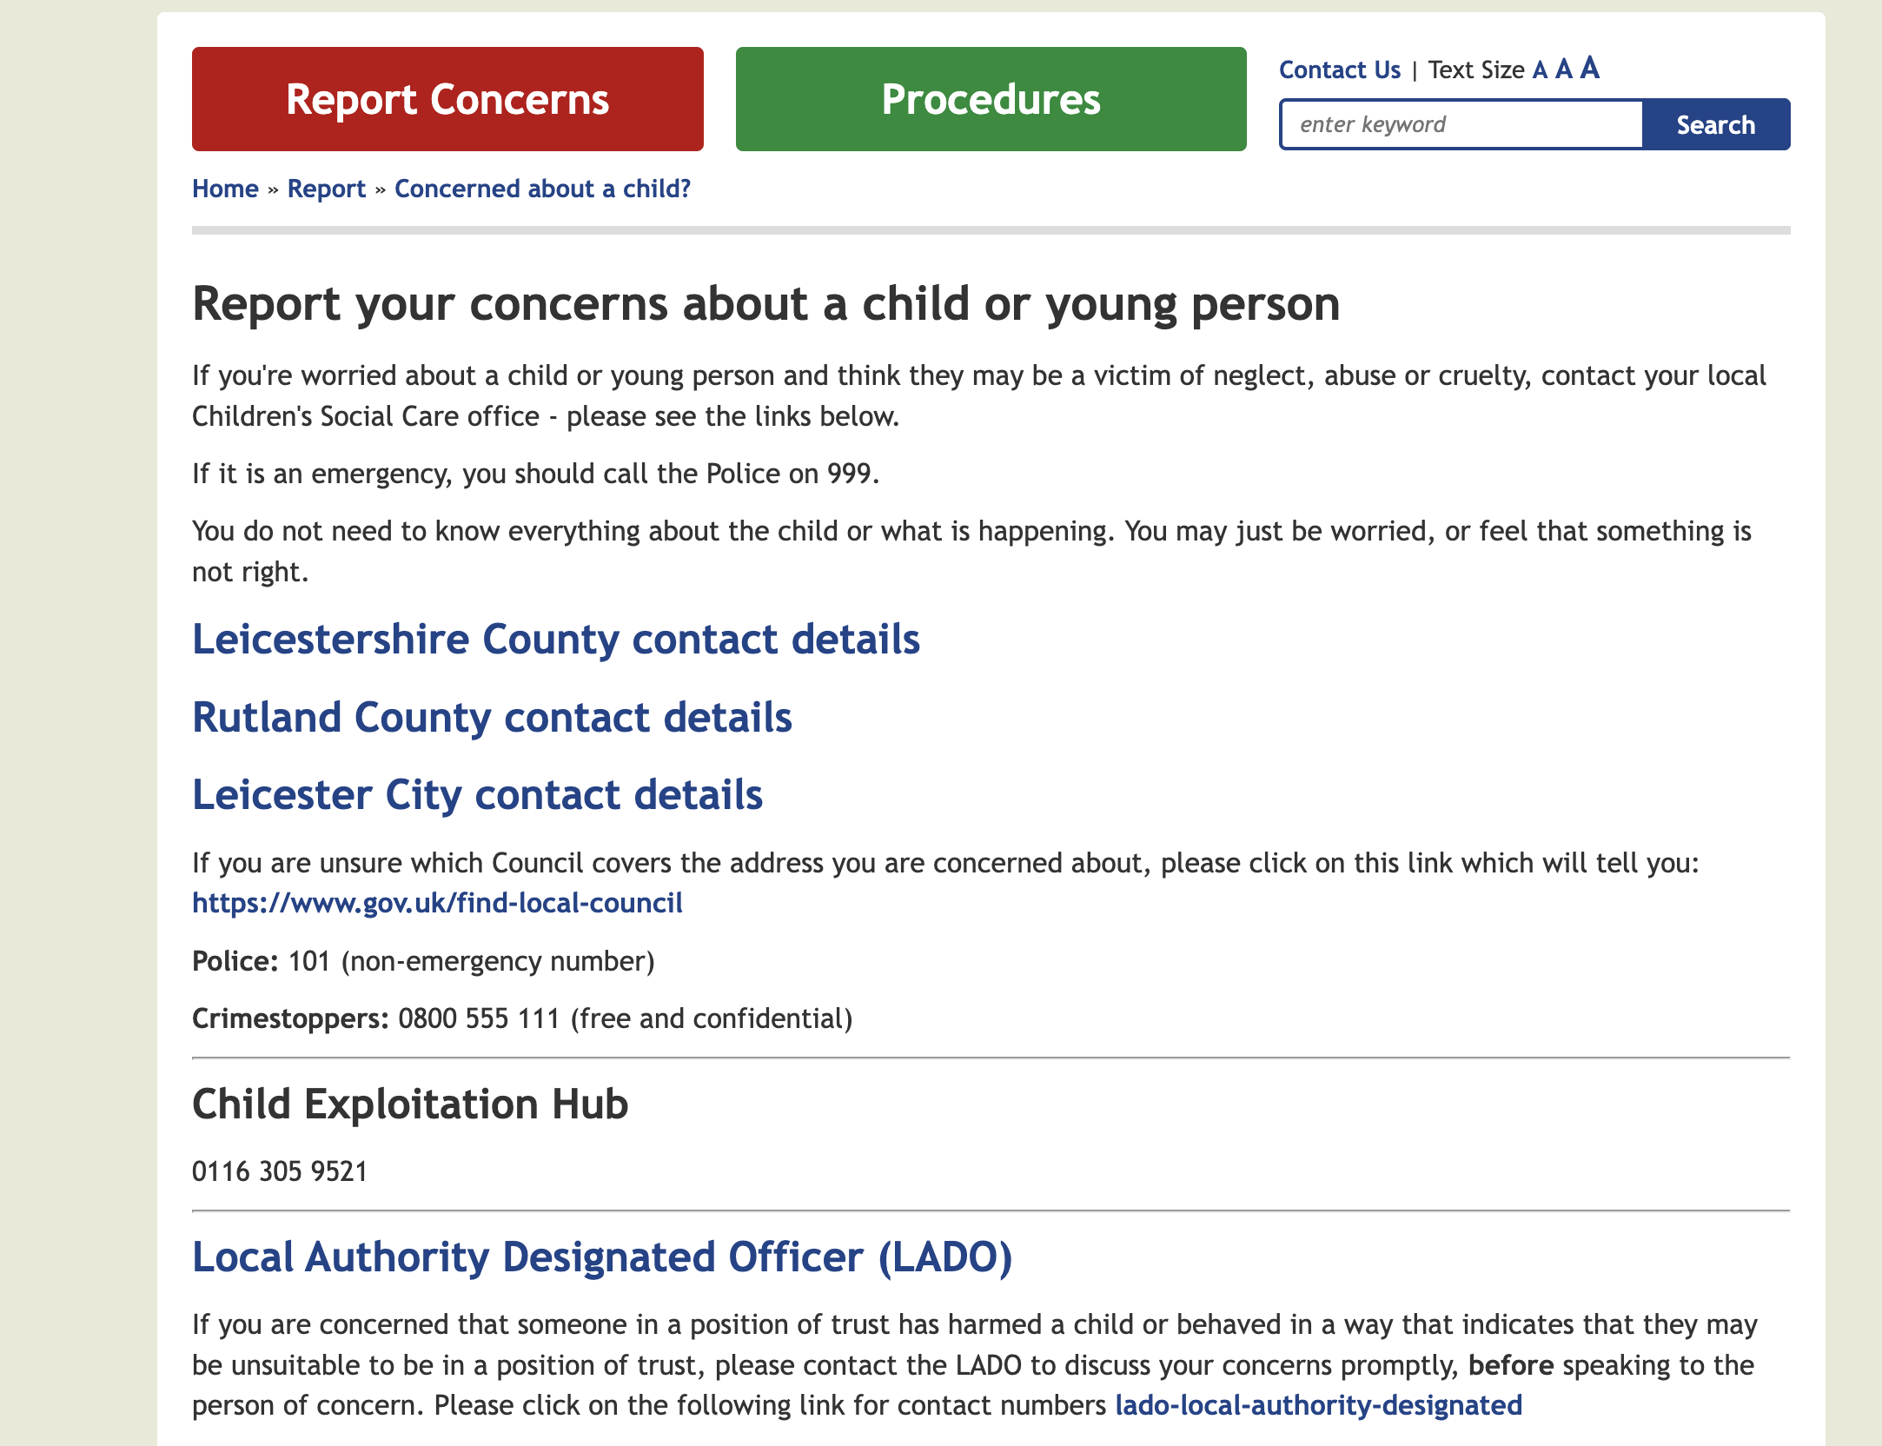

Leicestershire:

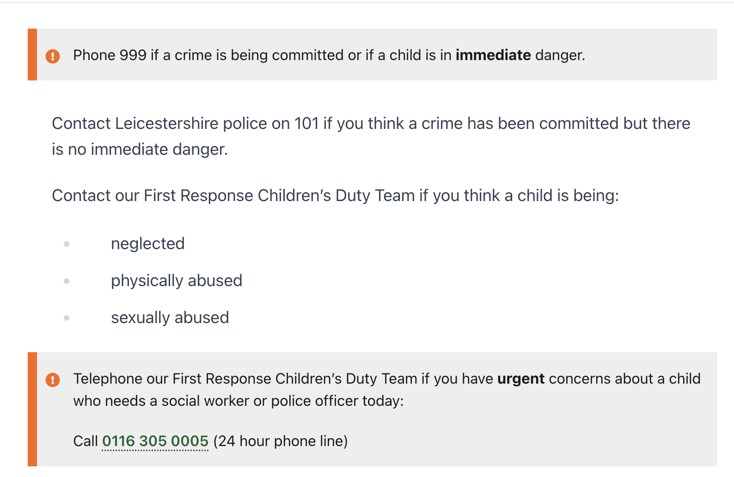

Rutland:
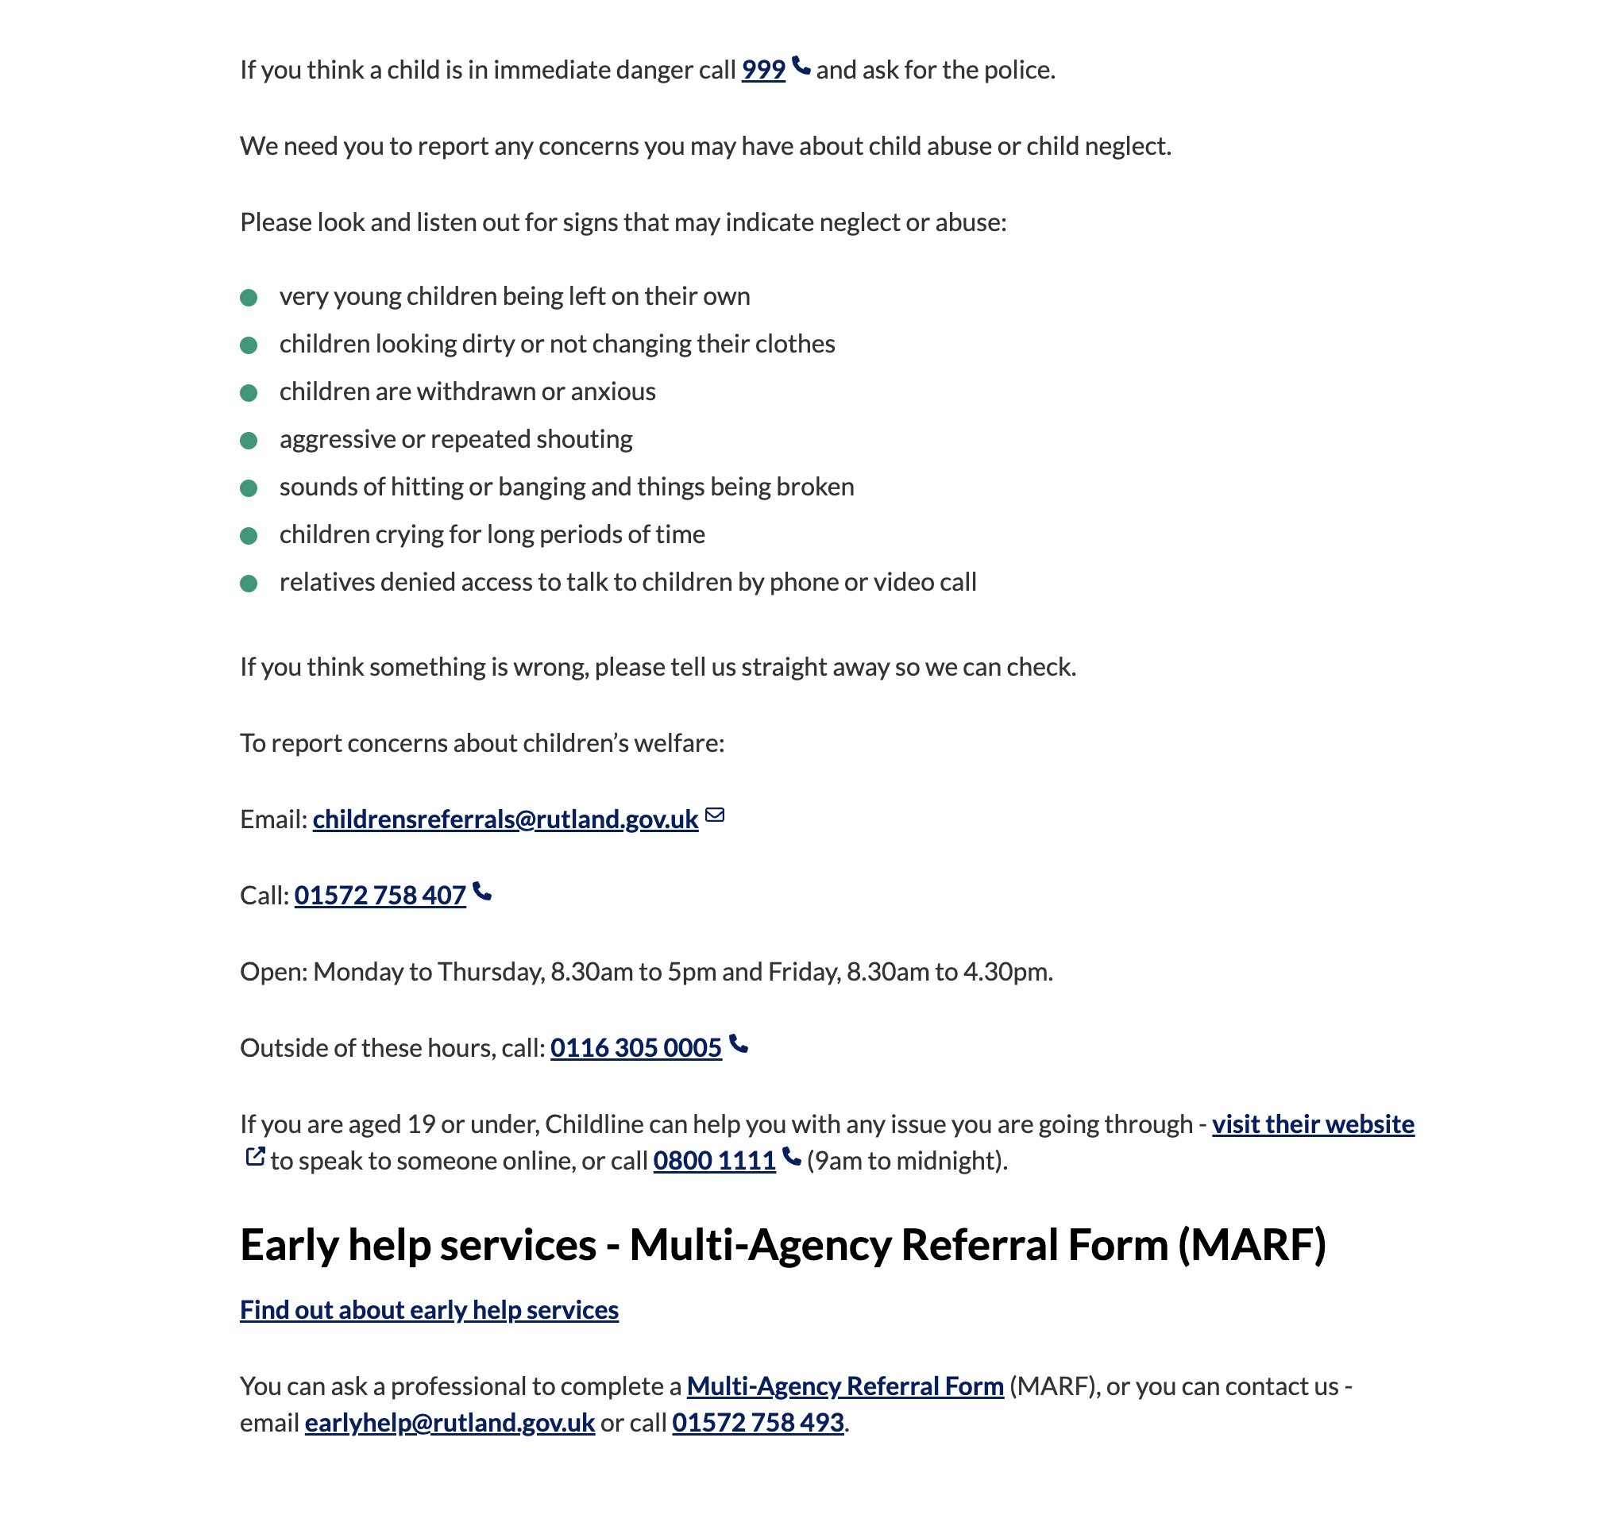
Leicester City

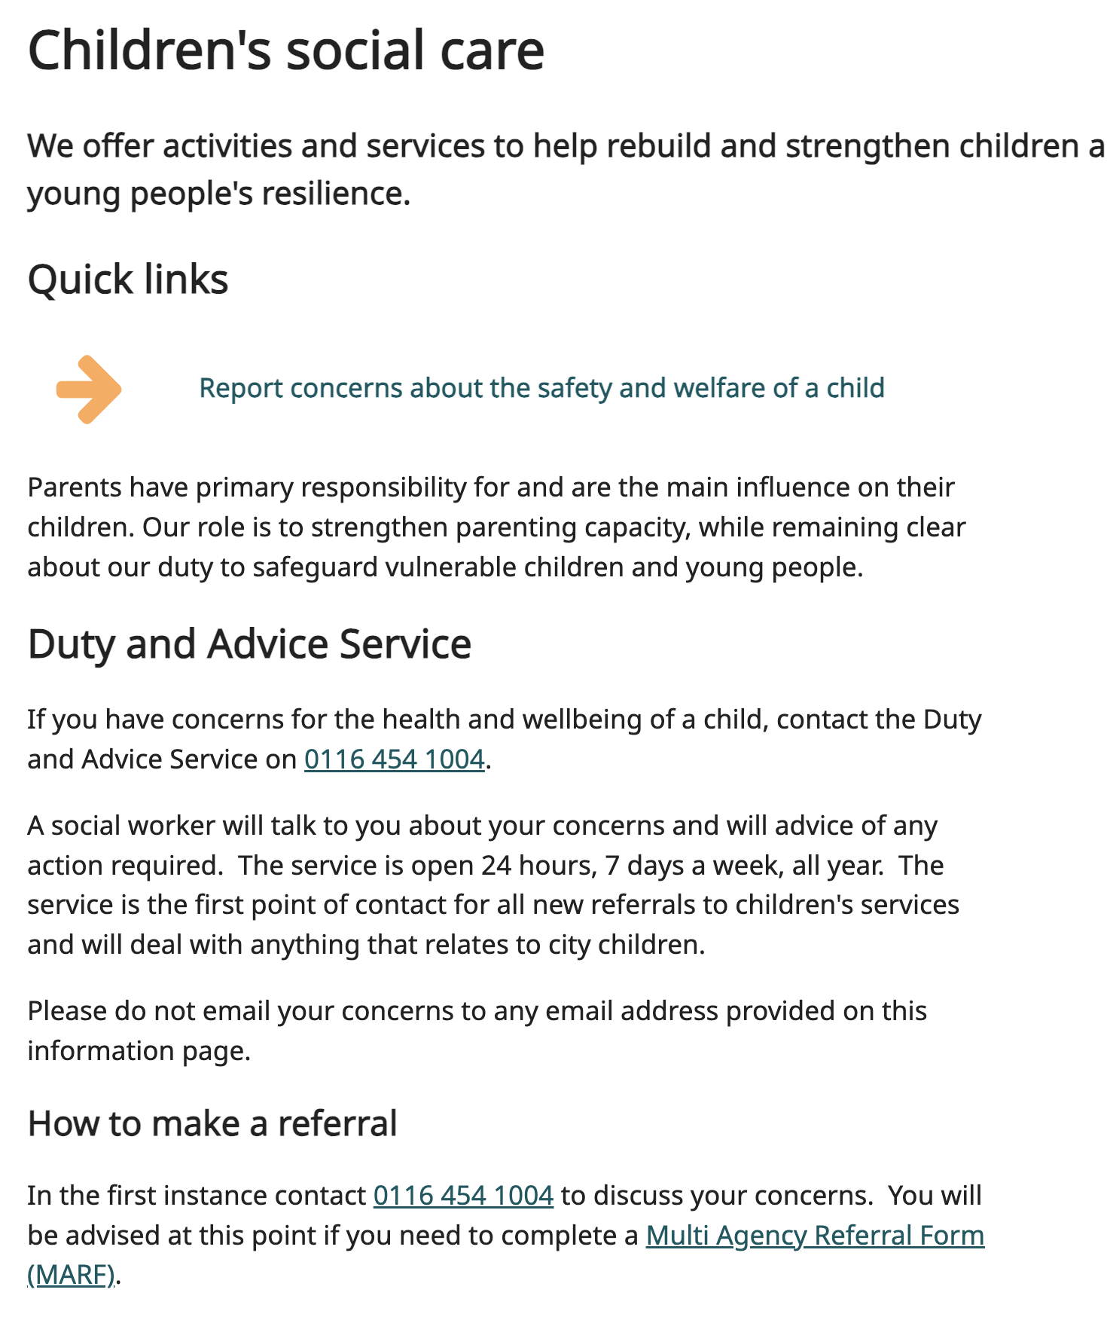

LADO for Leicestershire & Rutland Safeguarding Children Partnership:
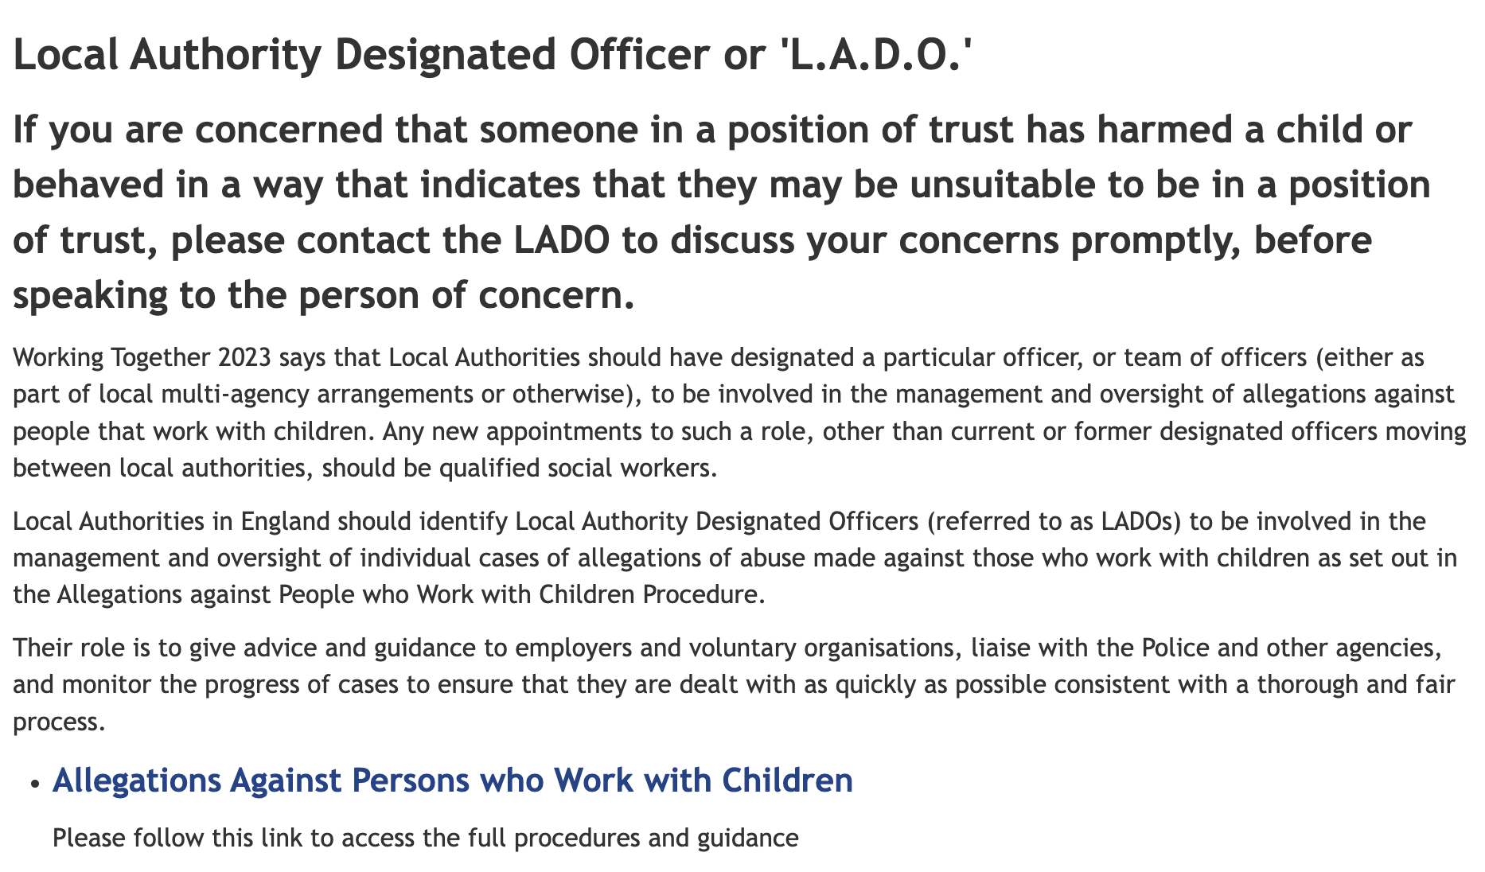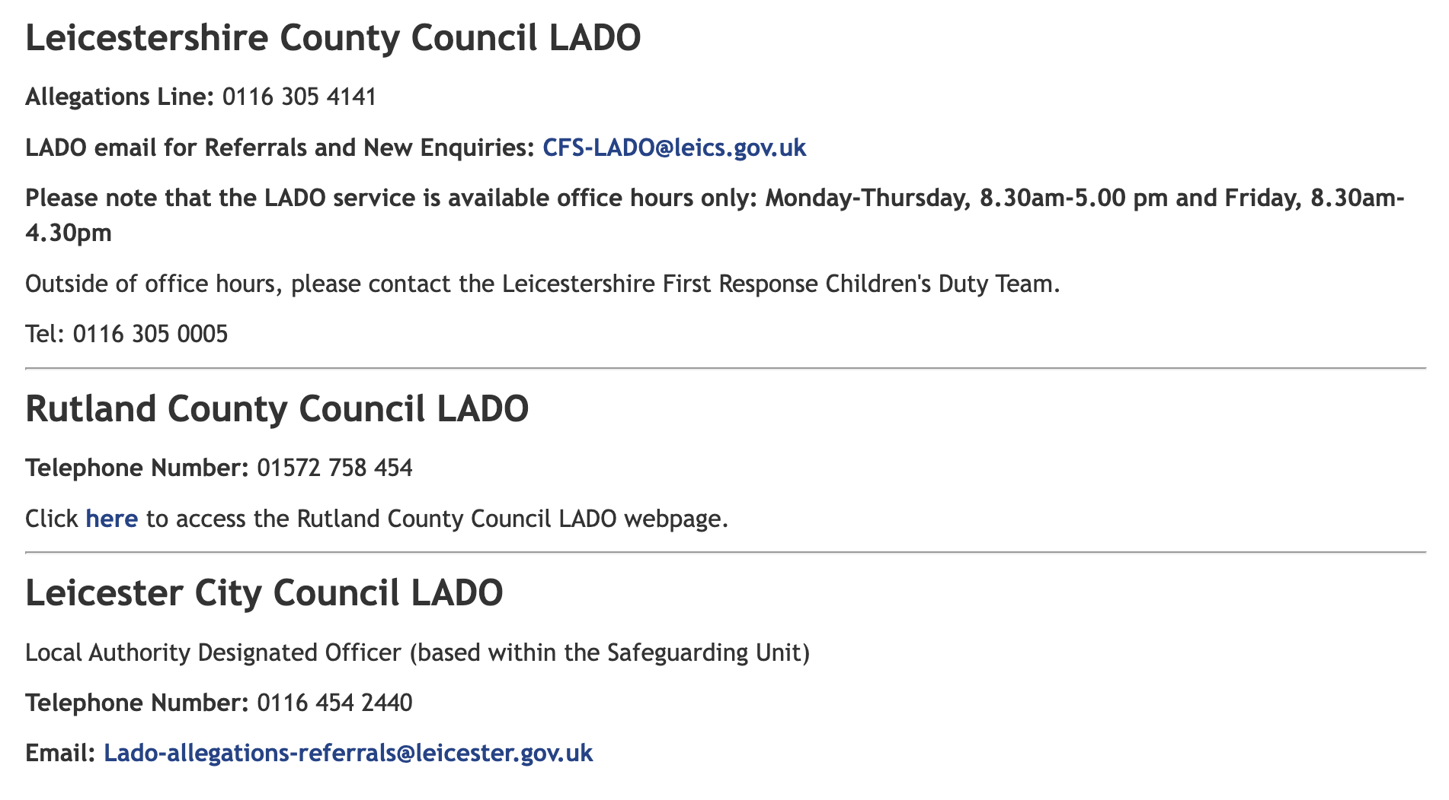

Northamptonshire
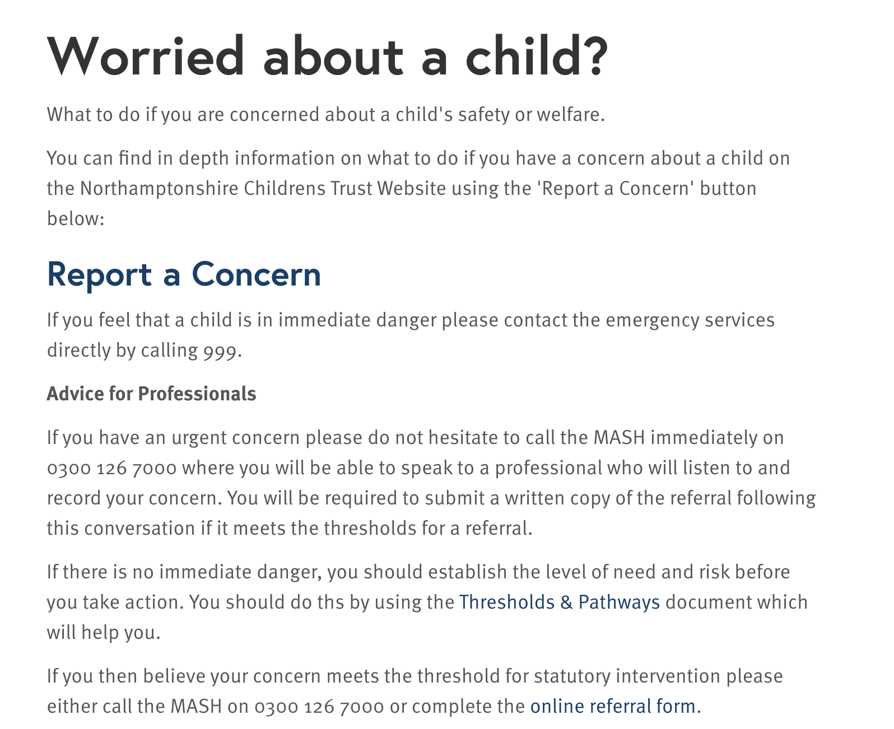

3.Safeguarding information for all staff
Safeguarding and promoting the welfare of children is defined in KCSIE (September 2026) as:
- providing help and support to meet the needs of children as soon as problems emerge;
- protecting children from maltreatment, whether that is within or outside the home, including online;
- preventing impairment of children’s mental and physical health or development;
- ensuring that children grow up in circumstances consistent with the provision of safe and effective care;
- promoting the upbringing of children with their birth parents, or otherwise their family network through a kinship care arrangement, whenever possible and where this is in the best interests of the children;
- Meadow View Farm School recognises that safeguarding begins before birth. Where concerns are identified regarding an unborn child, the school will work with health professionals, children's social care and safeguarding partners to ensure appropriate support and intervention.
- taking action to enable all children to have the best outcomes in line with the outcomes set out in the Children’s Social Care National Framework.

3.1 For the purposes of this policy, the term ‘safeguarding’ refers to everything Meadow View Farm School does to keep children safe and promote their welfare, including (but not limited to):
- Supporting students’ health, safety and well-being, including their mental health;
- Meeting the needs of children with special educational needs and/or disabilities;
- Meeting the needs of children with medical conditions;
- Providing first aid;
- Providing educational visits;
- Ensuring intimate care and emotional wellbeing needs are met;
- Maintaining a focus on online safety and associated issues;
- Ensuring appropriate arrangements are in place to ensure school security, taking into account the local context;
- Keeping children safe from risks, harm and exploitation; and
- Ensuring effective child protection procedures are in place and understood.

3.2 Child protection is part of safeguarding and refers to activities undertaken to prevent children suffering, or being likely to suffer, significant harm.
3.3 Abuse is a form of maltreatment of a child. Somebody may abuse or neglect a child by inflicting harm or by failing to act to prevent harm. Harm can include ill treatment that is not physical as well as the impact of witnessing ill treatment on others. This can be particularly relevant, for example, in relation to the impact on children of all forms of domestic abuse. Children may be abused in a family or in an institutional or community setting by those known to them or, more rarely, by others. Abuse can take place online and in person, please be aware that they are not mutually exclusive, and children can experience these types of abuse simultaneously. Children may be abused by an adult or adults or by another child or children.
3.4 Neglect is a form of abuse and is the persistent failure to meet a child’s basic physical and/or psychological needs, likely to result in the serious impairment of the child’s health or development.
3.5 Child on child abuse refers to the abuse of a child or children perpetrated by another child or children. Child on child abuse is most likely to include, but may not be limited to:
- bullying (including cyberbullying, prejudice-based and discriminatory bullying);
- exploitation;
- abuse in intimate personal relationships between children also known as teenage relationship abuse;
- physical abuse such as hitting, kicking, shaking, biting, hair pulling, or otherwise causing physical harm (this may include an online element which facilitates, threatens and/or encourages physical abuse);
- sexual violence, such as rape, assault by penetration and sexual assault (this may include an online element which facilitates, threatens and/or encourages sexual violence);
- sexual harassment, such as sexual comments, remarks, jokes and online sexual harassment, which may be standalone or part of a broader pattern of abuse;
- causing someone to engage in sexual activity without consent, such as forcing someone to strip, touch themselves sexually, or to engage in sexual activity with a third party;
- consensual and non-consensual sharing of nudes and semi-nude images and or videos (also known as sexting or youth produced sexual imagery);
- upskirting (which is a criminal offence), which typically involves taking a picture under a person’s clothing without their permission, with the intention of viewing their genitals or buttocks to obtain sexual gratification, or cause the victim humiliation, distress or alarm; and
- initiation/hazing type violence and rituals (this could include activities involving harassment, abuse or humiliation used as a way of initiating a person into a group and may also include an online element).
Keeping Children Safe in Education (2026)
3.4 Children includes everyone under the age of 18.
3.5 Terminology within this policy:
- Parent’ refers to birth parents and other adults in a parenting role, for example adoptive parents, stepparents and foster carers.
- ‘Staff’ or ‘members of staff’ refers to all teaching, non-teaching, support, supply, peripatetic, contract staff, governors, volunteers and trustees working in or on behalf of the school.
- Headteacher - This refers to the senior leader or manager who retains accountability for all safeguarding-related matters within the school or college.
3.6 Keeping Children Safe in Education (September 2026) may be abbreviated to ‘KCSIE’.
3.7 Child abuse is covered by the term “significant harm” and is defined in the Adoption and Children Act 2002 in the following way:
- “harm” means ill-treatment or the impairment of health or development
- “development” means physical, intellectual, emotional, social or behavioural development
- “health” means physical or mental health
- “ill-treatment” includes sexual abuse and forms of ill-treatment which are not physical.

4. Responsibilities to implement policy
4.1 Safeguarding and promoting the welfare of children is everyone’s responsibility. It is the duty of all staff, trustees, governors, volunteers, and visitors to Meadow View Farm School to accept and understand their responsibilities for safeguarding and to follow the agreed principles and procedures outlined in this policy read in conjunction with KCSIE 2026.

4.2 The Proprietary Body will:
- determine and keep under review the school’s safeguarding policy;
- ensure that an effective organisation is created for the management of safeguarding and child protection concerns;
- ensure that the school promotes the correct attitude towards safeguarding and child protection with staff, volunteers and visitors; and
- monitor and evaluate the effectiveness of the school’s safeguarding practices and procedures.
- Nominate a Safeguarding Director

4.3 All those involved in governance must attend all relevant induction and annual training. It is the responsibility of the Proprietary Body to ensure they have read and understood the KCSIE document (at least Part 1, Part 2 and Annex B) and this policy and have signed a declaration confirming this has been undertaken on appointment and each time the policy and KCSIE are updated.

4.4 Part 2 of KCSIE (September 2026) sets out the responsibilities of governing bodies and all those involved in governance will adhere to this guidance at all times.
This includes:
- working to facilitate a whole school to safeguarding, including child on child abuse, by ensuring that safeguarding and child protection underpin all relevant aspects of policy and process;
- ensuring that policies, procedures, and training are effective and comply with the law at all times and that they allow concerns to be responded to in a timely manner;
- ensuring that school has the systems in place to allow children to raise concerns, which are well-promoted, well-understood and easily accessible.
- Receiving regular safeguarding assurance regarding: filtering and monitoring; safeguarding audits; online safety; safeguarding training; multi-agency working; emerging safeguarding risks.

4.5 Director of Safeguarding have strategic responsibility for the standards, including quality of safeguarding provision. It is the responsibility of the Director of Safeguarding to:
- ensure that suitable arrangements are in place within school to satisfy the duties and arrangement as outlines in this policy, including ensuring that there is appropriate staffing with the required time, funding, resources and support;
- ensure, in co-ordination with the Head, that all relevant Senior Managers are capable and competent in their given roles and provided with suitable and sufficient information and instruction;
- maintain strategic oversight of the effectiveness of safeguarding;
- respond to low level concerns or allegations of abuse against Headteacher in line with the Low-Level Concerns and Dealing with Allegations Against Staff in Part 4 of KCSIE 2026.

4.6 Head teacher is accountable for the effective safeguarding of children in their school and will:
- ensure that this policy and associated procedures, including the use of CPOMS, are adhered to by all staff and take action as necessary if not;
- ensure that staff (including temporary staff) and volunteers are informed of systems and trained in using such systems, that support safeguarding, including this policy, as part of their induction

The headteacher:
- ensures that the child protection policy and procedures are understood and implemented by all staff;

- allocates sufficient time, training, support, and resources, including cover arrangements, when necessary, to enable the DSL and deputy/s to carry out their roles effectively, including the assessment of pupils and attendance at strategy discussions and other necessary meetings;

- supports the designated teacher for children in care to promote the educational achievement of any pupils who are children in care of the Local Authority or who have left care through adoption, special guardianship, or child arrangement orders or who were adopted from state care outside England and Wales;

- ensures that all staff have the skills, knowledge and understanding necessary to keep children in care and previously children in care safe;

- ensures that all staff feel able to raise concerns about poor or unsafe practice and that such concerns are handled sensitively and in accordance with the whistleblowing procedure;

- ensures that the culture of the school supports the provision of effective pastoral care and early help;

- ensures that staff do everything they can to support social workers when Children’s Social Care become involved;

- ensures that pupils are provided with opportunities throughout the curriculum to learn about safeguarding and how to keep themselves safe at all times, including when online, as part of a broad and balanced curriculum;

- refers all allegations that a child has been harmed by or that children may be at risk of harm from a member of staff or volunteer to the LADO within one working day prior to any internal investigation;

- ensures that anyone who has harmed or may pose a risk of harm to a child is referred to the Disclosure and Barring Service, as advised by the LADO;

- appoints a case officer who will be the Head to investigate allegations concerning members of staff and volunteers and/or act as a point of contact for the member of staff/volunteer against whom the allegation is made;

- ensures that all staff are made aware of the named director for safeguarding and the DSL;

- promotes an environment and culture of safety where students feel safe and listened to; this includes ensuring that the curriculum includes safeguarding and how to keep safe;

- ensures that the role of ‘DSL’ is explicit in the role-holder’s job description, that they have appropriate time, funding, training and resources and that there is always adequate cover if the DSL is absent;

- decides whether to have one or more deputy safeguarding leads and ensure they are trained to the same standard as the DSL;

- organises appropriate cover for the role of DSL for any out of hours/out of term activities;

- appoints a ‘Designated Teacher for Looked After and Previously Looked After Children’ to promote the educational achievement of children looked after and previously looked after;

- ensures the whistle blowing policy and procedures have been disseminated to all staff and that any allegations against staff are responded to appropriately;

- ensures all recruitment follows the safer recruitment guidance detailed in Part 3 of KCSIE and that a single central record is maintained with details of all members of staff who are in contact with children;

- responds to allegations of abuse/concerns against all other members of staff and acts as the ‘case manager’ in the event of an allegation of abuse/concerns made against another member of staff or volunteer, implementing the appropriate disciplinary and appeals procedures as required;

- refers cases where a person is dismissed or has left due to risk/harm to a child to the Disclosure and Barring Service as required;

- ensures that school staff works with social care, the police, health services and other services to; promote the welfare of children; provide a co-ordinated offer of early help when need is identified; contribute to inter-agency plans for children subject to children protection plans and to protect children from harm;

- safeguards children’s wellbeing and maintain public trust in the teaching profession as part of their professional duties (Teaching Standards, 2012);

- ensures that children’s social care (from the host local authority or placing authority) have access to the DSL to conduct, or to consider whether to conduct a section 47 or section 17 assessment, as per KCSIE (September 2026);

- ensures the relevant staffing ratios are met, where applicable; and

- contributes to safeguarding quality assurance activities; and

The headteacher will retain accountability for all safeguarding-related matters within Meadow View Farm School.

4.7 Designated Safeguarding Leads (DSL) The DSL is a member of the Senior Leadership Team. The DSL takes lead responsibility for child protection and wider safeguarding. This includes online safety and an understanding of the filtering and monitoring systems in place. All DSLs will be given additional time, funding, training, resources and support to carry out their role effectively. The school’s DSL and their deputies are named on p.1. The full responsibilities of the DSL are set out in Annex C, KCSIE (2026).

4.8 When the DSL is absent, the Deputy DSL will cover. If they are not available, a member of SLT will cover. Any deputies will be trained to the same standard as the designated safeguarding lead. Whilst the activities of the DSL can be delegated to appropriately trained deputies, the ultimate lead responsibility for child protection, as set out above, remains with the designated safeguarding lead; this lead responsibility should not be delegated.

4.9 Meadow View Farm School recognises the pressures inherent within the role of DSLs and DDSLs, and the demands placed upon them. To preserve staff wellbeing, Meadow View Farm School does not expect DSLs or DDSLs to monitor emails, phonelines or CPOMS (child protection recording software) outside of working hours, except during periods of planned school trips or activities. All members of the school community (staff, parents, and students) will be made aware of this expectation. Where staff are not contracted to work outside of termtime, an emergency rota will be in place covering normal working hours during holiday periods but excluding bank holidays and weekends. To promote the safety of children during these times, Meadow View Farm School will regularly share contact details for statutory and non-statutory support services, including police and children social care, with all members of the school community, including via the school’s website.

4.10 The DSL will:
- Ensure safeguarding practice reflects current statutory guidance, including anti-discriminatory practice, safeguarding unborn children where appropriate, and effective multi-agency working.
- act as a source of support and expertise on matters relating to safeguarding and child protection to ensure that other members of staff can carry out their safeguarding duty;
- provide oversight, support and challenge to DDSLs;
- act as a point of contact with the safeguarding partners and engage fully with requests for information (e.g., Section 175 audit);
- perform the role of Online Safety Lead;
- be aware of and up to date with latest national and local guidance and requirements, ensuring this is shared with all key personnel.
- advise on the response to safeguarding concerns, ensuring that all safeguarding concerns raised by staff are properly assessed, categorised, actioned and resolved, and ensuring that decisions and rationales are clearly recorded;
- liaise with the Local Authority and work with other agencies in line with ‘Working Together to Safeguard Children (2026);
- be aware of the requirement for children to have an Appropriate Adult and follow the procedures outlined in searching screening and confiscation 2022;
- identify if children may benefit from Early Help
- refer suspected cases, as appropriate, to the relevant body (local authority children’s social care, Channel programme, Disclosure and Barring Service, and/or police), and support staff who make such referrals directly;
- make referrals to the Channel programme where there is a radicalisation concern and/or support staff that make a referral to Channel;
- support the headteacher with regards to their responsibilities under the Prevent duty and provide advice and support on protecting children from radicalisation;
- refer cases to the police where a crime may have been committed with reference to When to call the police NPCC;
- be available during school hours for staff to discuss any safeguarding concerns. In the event that they are not available, a deputy will be made available;
- undertake training to equip them with the skills to carry out the role and update this every two years;
- maintain a forensic understanding of safeguarding data, including data relating to child-on-child abuse;
- ensure all staff that work directly with children have read and understood Part 1 and Annex B of KCSIE (September 2026);
- ensure all staff that do not work directly with children have read either Part 1 of KCSIE (2026);
- update their knowledge and skills regularly and keep up with any developments relevant to their role;
- provide staff in the school with the knowledge, skills and support required to safeguard children;
- ensure that all school staff and those working with the school receive initial training and appropriate regular update training via whole staff training or bulletins on safeguarding, including how to recognise the signs and symptoms of abuse. This includes provision of training on how to report a safeguarding concern through the CPOMS.
- ensure that all staff can demonstrate an understanding of child abuse, neglect and exploitation and their main indicators, including for children in care (looked after children). Staff can also demonstrate an understand of wider safeguarding issues (details in Annex B of KCSIE) and the additional vulnerabilities of children with special educational needs and disabilities or those who identify as gender questioning.
- take responsibility for the accurate and timely recording of safeguarding and child protection concerns and take overall responsibility for safeguarding and child protection files;
- take responsibility for the transfer of safeguarding files when a child leaves their school adhering to KCSIE’s five school day transfer limit;
- monitor school mobility, and in particular take responsibility for ensuring that those children removed from the school are removed in adherence with LA guidance, ensuring that all reasonable steps are taken to ensure that the child is safe;
- attend or ensure an appropriate representative attends multi-agency safeguarding or child protection meetings;
- ensure that parents and carers are informed of the safeguarding procedures by a statement in the school’s prospectus, access to the policy and procedures on the school website and reminders via newsletters;
- work closely with other relevant education professionals (e.g., SENCO, Virtual Schools Head) to ensure children with additional vulnerabilities are safeguarded;
- help to promote educational outcomes of children who have experienced or are experiencing safeguarding or child protection issues by sharing relevant information with teachers and the school’s leadership team;
- promote a ‘culture of safeguarding’, in which every member of the school community acts in the best interests of the child;
- meet regularly with the safeguarding director to review safeguarding at the school;
- meet regularly with relevant curriculum leads to share information about emerging trends and ensure that the safeguarding curriculum is meeting the needs of students;
- meet regularly with the school Business Manager to ensure that safe recruitment practices are in place and effective, including checking that the School’s Single Central Record is maintained in line with statutory guidance;
- contribute to safeguarding quality assurance activities;
- Liaise with the headteacher regarding safeguarding cases and issues.

4.11 All staff play a particularly important role because they are in a position to identify concerns in order to provide help for children.
All staff:
- have a responsibility to provide a safe environment, where children can learn;
- will be made aware of and should be clear on the school’s policy and procedures with regards to safeguarding and child-on-child abuse and the important role they have to play in preventing it and responding where they believe a child may be at risk from it;
- will complete mandatory training provided by the school so that they know and understand: how to identify indicators of neglect, harm and abuse and the behaviours associated with these risks; what to do if a child discloses information which is a safeguarding concern (including FGM); what safeguarding systems are in place within the school, including the use of CPOMS for recording concerns, decisions, actions, and outcomes;
- must be aware of who the safeguarding team are;
- are responsible for ensuring that they have read and understood key policies (contained within the Safeguarding Portfolio on the school’s Drive) such as the Acceptable Use Policy, Staff Conduct Policy and the Safeguarding and Child Protection Policy. Staff must also regularly familiarise themselves with the key information contained in Annex B of KCSIE 2026 in conjunction with this policy;
- should be prepared to make referrals to the Front Door/First Response if they are concerned that a child is suffering, or likely to suffer, significant harm and understand the role that they may be expected to play in social care assessments;
- will be encouraged to contribute to the development of safeguarding policy and practice.
- Staff should understand that safeguarding requires professional curiosity and respectful challenge where appropriate. Staff should recognise that children and families may face barriers to seeking help and should actively consider these during assessment and decision-making.

4.12 All staff that work directly with children will be provided with a copy of, and must read, Part 1 and Annex B of KCSIE annually and will receive ongoing training to maintain knowledge and skills including safeguarding roles and responsibilities. Staff that do not work directly with children will be provided with a copy of Part 1 of KCSIE (2026) and must read this document. In either case, all members of staff must sign a declaration confirming they have done this. Schools will make use a variety of methods to assess staff understanding.

4.13 Although there are extensive mechanisms in place to support staff understanding in relation to safeguarding and child protection, there is an expectation that if staff are unclear on any aspects of school’s safeguarding policy or practice, they speak to the DSL or Head of Safeguarding immediately, so that additional training can be arranged.
4.14 The DSL will set the strategic safeguarding direction for the school, working in an advisory capacity to provide support and guidance to DDSLs on all safeguarding related matters.
The main areas of responsibility include:
- Strategic oversight of developing safeguarding and child protection ensuring statutory compliance and development of this area;
- Developing, implementing, and evaluating the impact of an annual safeguarding action plan to promote effective quality assurance and practice improvement;
- Representing the school within strategic multi-agency partnerships;
- Implementing of the safeguarding policy and other relevant policies including attendance;
- Implementing the safeguarding action plan to support school to identify and respond to statutory and emerging training needs;
- Providing or facilitating the provision of advice, guidance and coaching support to DDSLs on complex safeguarding cases.

5. Recognising and responding to abuse
5.1 If a member of staff, parent or member of the public is concerned about the safety or welfare of a child, they should report it to the DSL as soon as possible. If the DSL is not available, it should be reported to the deputy safeguarding lead/s immediately. If in exceptional circumstances, the DSL (or deputy) is not available, this should not delay appropriate action being taken. Staff should consider speaking to a member of the senior leadership team and/or take advice from local children’s social care, Front Door.
5.2 Although any member of staff can make a referral to children’s social care, Front Door, where possible there should be a conversation with the DSL. All staff must follow the procedures set out below in the event of a safeguarding issue.
5.3 All staff will be alert to indicators of abuse (including child on child, online abuse, and exploitation) and will report any of the following to the Designated Safeguarding Lead immediately;
- any concern or suspicion that a child has sustained an injury outside what is reasonably attributable to normal play;
- any concerning behaviours exhibited by children that may indicate that they have been harmed or are at risk of harm, including unusual changes in mood or behaviour, concerning use of language and/or concerning drawings or stories;
- any significant changes in attendance or punctuality;
- any significant changes in a child’s presentation;
- any indicators that a child may be experiencing child on child abuse;
- any concerns relating to people who may pose a risk of harm to a child; and/or
- any disclosures of abuse that children have made.
5.4 More information about our approach to child-on-child abuse (including sexual violence and sexual harassment) can be found in specific safeguarding issues, please see Part One, Part Five and Annex B of KCSIE,2026.

5.5 Responding to a Disclosure When responding to a disclosure from a child, staff will:
- listen to what is being said without displaying shock, disbelief or other emotion;
- accept what is being said;
- allow the child to talk freely;
- reassure the child, but not make promises which might not be possible to keep;
- never promise a child that they will not tell anyone – it may not be in their best interest;
- reassure them that what has happened is not their fault;
- stress that it was the right thing to tell;
- listen, only asking questions when necessary to clarify – do not investigate;
- not criticise the alleged perpetrator;
- explain what has to be done next and who has to be told;
- not ask students to write a written record of their disclosure;
- reassure the victim they are being taken seriously and they will be supported and kept safe. A victim should never be given the impression they are creating a problem by reporting abuse (including sexual violence and sexual harassment), nor should a victim ever be made to feel ashamed for making a report;

5.6 Reporting and Recording a Concern All staff and volunteers receive guidance on the procedures to report safeguarding concerns upon induction and receive regular updates. All concerns should be reported in writing, and handed to a DSL who will then add it to CPOMs with the necessary actions and outcomes. Records should be created as soon as possible, on the same day and during working hours. Staff should never wait until the next day to complete a safeguarding concern report.

All staff and volunteers will
- make a written record, informing the child that you are doing so;
- pass the information to the DSL and DDSL without delay, in person. All concerns MUST be verbally handed over to a DSL. All reports to the DSL must be followed up in writing as soon as possible, signed and dated at the end of the report.

5.7 The DSL/DDSL will then
- keep a confidential record of all comments, actions, and observations. These records will be filed, kept securely and access will be restricted to only staff authorised by the DSL, or Headteacher.
- seek to discuss any concerns about a student with their parents. This must be handled sensitively and the DSL or the DDSL will contact the parent in the event of a concern, suspicion or disclosure. However, if the DSL or the DDSL believes that notifying parents could increase the risk to the child or exacerbate the problem, advice will first be sought from Front Door/First Response (depending on the LA)
- If the DSL or the DDSL believes that “a child is experiencing or may have already experienced abuse or neglect” or “is at risk of suffering significant harm” either now or in the future, then the school will comply with the procedures of the Local Safeguarding Partnership. (detailed on page 7)
5.8 Concerns About Significant Harm or Imminent Danger Any member of staff that suspects or has evidence of child abuse or is concerned that a child may be at risk of imminent danger, must notify the DSL or a DDSL immediately and in person. A referral must be made if a child may be suffering or at risk of suffering harm. Whilst the DSL or a DDSL should ideally make the referral, anyone can make a referral to children’s social care, Front Door/First Response. If anyone other than the DSL makes a referral to children’s social care or to the police, they should inform the DSL as soon as possible.
5.9 Concerns Below the Threshold for Significant Harm and No Imminent Danger Staff should log concerns on CPOMS (having verbally handed them over to DSL), at the earliest opportunity, providing sufficient information and context for the DSL/DDSL to assess the information. The DSL will decide on the most appropriate course of action and whether the concerns should be referred to Front Door, using the thresholds guidance Spectrum of Support (applicable to the child’s residing LA), published by the local safeguarding partnership or whether a referral for Early Help will benefit the child. If it is decided to make a referral to children’s social care the parent will be informed, unless to do so would place the child at further risk or undermine the collection of evidence.

All concerns, discussions and decisions will be recorded in writing. The DSL will provide guidance on the appropriate action. Options will include:
- managing any support for the child internally via the school’s own pastoral support processes.
- an Early Help Pathway Assessment; or
- a referral for statutory services where the child is, or might be, in need or suffering or likely to suffer significant harm.
5.10 Early Help and Vulnerable Children All staff should be prepared to identify children who may benefit from early help. Early help means providing support as soon as a problem emerges at any point in a child’s life. If early help is appropriate, the DSL or DDSL will generally lead on liaising with other agencies and setting up an interagency assessment as appropriate. Staff may be required to support, in some cases acting as the lead practitioner. Any such cases should be kept under constant review and consideration given to a referral to children’s social care for assessment for statutory services if the child’s situation does not appear to be improving or is getting worse. Timelines of interventions will be monitored and reviewed.

All staff will be made aware of the early help process, and understand their role in identifying emerging problems, sharing information with other professionals to support early identification and assessment of a child’s needs. It is important for children to receive the right help at the right time to address risks and prevent issues escalating. This also includes staff monitoring the situation and feeding back to the DSL or DDSL any ongoing/escalating concerns so that consideration can be given to a referral to children’s social care if the child’s situation does not appear to be improving. We recognise that any child can be the victim of abuse and may benefit from early help. However, we will be particularly vigilant to potential need for early help if a child;
- is disabled or has certain health conditions and has specific additional needs;
- has special educational needs (all children at MVFS have a statutory Education, Health and Care Plan (EHCP));
- has a mental health need;
- is a young carer;
- is showing signs of being drawn in to anti-social or criminal behaviour, including gang involvement and association with organised crime groups or county lines;
- is frequently missing/goes missing from care or from home;
- has persistent or unexplained absence from education;
- has experienced multiple suspensions, is at risk of being permanently excluded from schools and in Alternative Provision or a Pupil Referral Unit.
- is at risk of modern slavery, trafficking, sexual or criminal exploitation;
- is at risk of being radicalised or exploited;
- has a parent or carer in custody, or is affected by parental offending
- is in a family circumstance presenting challenges for the child, such as drug and alcohol misuse, adult mental health issues and domestic abuse;
- is misusing drugs or alcohol themselves;
- has returned home to their family from care;
- is at risk of so-called ‘honour’-based abuse such as Female Genital Mutilation or Forced Marriage; and
- is a privately fostered child;

The DSL will maintain a list of students who the school has identified to be at potential risk, including those with a social worker, and ensure that relevant staff are aware and that these students are monitored closely and supported to achieve the best possible outcomes. This will include children in care (looked after children, or previously looked after children), or those who have special educational needs or disabilities.

5.11 Referrals If it is appropriate to refer the case to local authority children’s social care or the police, the DSL will make the referral or support you to do so. If you make a referral directly you must tell the DSL as soon as possible. Children’s social care assessments should consider where children are being harmed in contexts outside the home, so the school will provide as much information as possible as part of the referral process. This will allow any assessment to consider all the available evidence and enable a contextual approach to address such harm. The school will be guided by Front Door as to the appropriate outcome e.g., complete an Early Help Pathway Assessment or refer to a relevant specialist agency. All Child Protection records, including referrals, will be maintained in a confidential file accessible only by DSLs. The protocols as outlined in the Data Protection Policy must be followed.
The local authority will decide within 1 working day of a referral about what course of action to take and will inform the referrer of the outcome. The DSL or person who made the referral must follow up with the local authority if this information is not made available, and ensure outcomes are properly recorded. If the child’s situation does not seem to be improving after the referral, the DSL or person who made the referral must follow local escalation procedures to ensure their concerns have been addressed and that the child’s situation improves. All escalations must be recorded on CPOMS. The DSL should refer all cases of suspected abuse or neglect to the Front Door, police (cases where a crime may have been committed) and to the Channel programme where there is a radicalisation concern. Consent will be required before support can be delivered to any individual through the Channel programme. Contact details for the Front Door/First Response can be found in Section 1 of this policy.

5.12 Trigger Points and Escalation In the event of serious incidents, the Head teacher should be notified by the DSL. The Director for Safeguarding will also be informed.

6. Responding to safeguarding issues
The following overview details how Meadow View Farm School will respond to specific safeguarding issues. The list is not exhaustive and is designed to complement the contents of Keeping Children Safe in Education (2026). Staff should follow the procedures outlined above when responding to, recording, and reporting the specific safeguarding issues detailed below. The response of DSLs and DDSLs will always be guided by KSCIE (2026) and multi-agency policies and procedures implemented by the safeguarding partnership.

6.1 Female Genital Mutilation FGM is a collective term for all procedures involving the partial or total removal of external female genitalia for cultural or other nontherapeutic reasons. Whilst all staff should speak to the designated safeguarding lead (or deputy) with regard to any concerns about female genital mutilation (FGM), the Female Genital Mutilation Act 2003 (as amended by the Serious Crime Act 2015) places a statutory duty upon teachers. If a teacher, in the course of their work in the profession, discovers that an act of FGM appears to have been carried out on a girl under the age of 18, the teacher must report this to the police.

6.2 Forced Marriage A forced marriage is where one or both people do not (or in cases of people with learning disabilities, cannot) consent to the marriage and pressure or abuse is used. A marriage must be entered into with the free and full consent of both parties, there must be a choice. Forced marriage is a crime. Since 2023, it has also been a crime for a person to carry out any conduct whose purpose is to cause a child to marry before their eighteenth birthday, even if violence, threats or another form of coercion are not used. As with the existing forced marriage law, this applies to non-binding, unofficial ‘marriages’ as well as legal marriages.

When responding to concerns regarding Forced Marriage, advice can be sought from the Forced Marriage Unit:
Telephone - (0) 20 7008 0151
Email - fmu@fcdo.gov.uk

6.3 Breast Ironing/Flattening Breast ironing or flattening is the process during which young pubescent girls’ breasts are ironed, massaged, flattened and/or pounded down over a period of time (sometimes years) in order for the breasts to disappear or delay the development of the breasts entirely. Girls aged between 9 and 15 have hot pestles, stones or other implements rubbed on their developing breast to stop them growing further. In the vast majority of known cases breast ironing is carried out by mothers or grandmothers and the men in the family are unaware. Breast ironing is a form of physical abuse. Staff or volunteers worried about the risk of breast ironing should report their concerns to the DSL immediately, who will make a referral to the Front Door.
If staff or volunteers are concerned that a student is in immediate danger, they should contact the police immediately by calling 999.
The DSL will contact the Foreign and Commonwealth Office if the student has been taken abroad:
Telephone – 020 7008 1500

6.4 Radicalisation and Extremism Meadow View Farm School has a statutory duty under Section 26 of The Counter-Terrorism and Security Act 2015 and the statutory Prevent Guidance 2015 to have due regard to the need to prevent people from being drawn into terrorism.
The Prevent Duty Guidance requires school to:
a) Assess the local risk of extremism – School should assess the risk of children being drawn into terrorism (appendix 5). This assessment should be carried out alongside key partners of the school, based on the local environment and informed by the Counter Terrorism Local Profile. The risk assessment will inform the school’s strategic approach to the prevention of radicalisation and extremism, including training and online filtering and monitoring.
b) Work in partnership – Meadow View Farm School will ensure that they follow the policies and procedures of the local safeguarding partnership. Staff will work closely with the police and local Prevent co-ordinator.
c) Train Staff – all staff will complete Prevent training at least every three years (or sooner if required). This will ensure that staff have the confidence to identify children suspensible to and at risk, to extremist ideas and should know where and how to refer children and for further help. DSLs will also complete training on the Channel process.
d) Implement ICT Policies – Meadow View Farm School will take steps to protect children online by ensuring appropriate levels of filtering and monitoring. More information can be found in the Online Safety policy.

Meadow View Farm School is committed to ensuring that all students benefit from a broad and balanced curriculum that prepares them for life in modern Britain. Fundamental British Values underpin all aspects of the education and curriculum offered to students. More information on the Channel process can be found on the LA’s websites and through contacting the LA’s Prevent officers/coordinators:
Geoff Thomas – WCC Prevent Officer
Ailsa Coull- Leicester City Council
Manjeet Pangli- Coventry City
National Police Prevent Advice Line- 0800 011 3164

6.5 Child on Child Abuse All staff should be aware that children can abuse other children either inside or outside of the school and respond to any concerns with the same rigour as they would for those involving adults. Meadow View Farm School does not accept and will not tolerate child on child abuse of any kind. Measures to minimise these risks are included in the Anti-bullying and Behaviour and Regulation policies, which should be applied in conjunction with the Safeguarding and Child Protection policy.

6.6 Online Safety Online safety is an integral part of safeguarding and requires a whole school, cross-curricular approach and collaboration between key school leads. This includes meeting the DfE’s Filtering and Monitoring and Digital and Technology Standards, including cyber security. Accordingly, the Online Safety Policy and associated Acceptable Use Policies are written in line with these standards, in addition to KCSIE (2026) ‘Teaching Online Safety in Schools’ 2019, statutory RSHE guidance 2019 and other relevant statutory and non-statutory guidance. There have been recent updates to include new content on: online misogyny, AI, deepfakes, online scams, and disinformation. The online safety policy and associated policies will be amended to reflect these updates and include the recognition of misinformation, disinformation, AI-related risks, and fake news as safeguarding concerns. Technology, and the risk and harms associated with it, evolves and change rapidly. The school will carry out an annual review of their approach to online safety, overseen by the DSL. The Online Safety Lead (DDSL & deputy Head) will work with relevant curriculum leads to ensure that online safety is embedded within the curriculum. This will include ensuring that the curriculum is inclusive and accessible and reflects the heightened vulnerability of some students online (e.g., students with SEND). Our school makes use of filtering and monitoring to block inappropriate content and monitor student internet on school-owned devices, or any other student device accessing the school network. Monitoring includes an element of external and human moderation, recognising the responsibility of staff in educating and monitoring children’s online activity- especially those vulnerable to exploitation. Concerns are logged directly on to CPOMS and brought to the attention of the DSL. Monitoring does not apply when students access the internet via their own devices and via 3G, 4G and 5G. The school will teach students about the acceptable use of technology, recognising online risk and ways to stay safe online, including when using personal devices. The school will encourage students to report any incidents relating to harmful content, conduct or contact. Where such incidents are caused by the behaviour of another student, the Behaviour and Regulation Policy will be applied. Policies in relation to the use of mobile phones and wearable devices by students and staff will be available in school/ on website (see appendix 3). Meadow View Farm School will take all reasonable action to limit children’s exposure to online risks when accessing the IT system. This includes ensuring that school has appropriate filtering and monitoring systems in place and ensuring that their effectiveness is reviewed regularly. This will include considering the number and age range of children, those who are potentially at greater risk of harm and how often they access the IT, along with the proportionality of costs versus safeguarding risks. The appropriateness of filtering and monitoring systems is managed by school, including risk assessments for individuals where necessary. Where a safeguarding concern for a student relates to online safety, usual safeguarding procedures in relation to responding, recording and reporting will apply. This may lead to the provision of school-based interventions, early help, or referral to the police or Front Door/First Response. The response will be overseen by the DSL. More detailed guidance can be found in the Online Safety Policy. The DSL will ensure the school's filtering and monitoring provision is reviewed annually against the DfE Filtering and Monitoring Standards.

6.7 Child Sexual Exploitation (CSE) and Child Criminal Exploitation (CCE) Both CSE and CCE are forms of abuse that occur where an individual or group takes advantage of an imbalance in power to coerce, manipulate or deceive a child into taking part in sexual or criminal activity, in exchange for something the victim needs or wants, and/or for the financial advantage or increased status of the perpetrator or facilitator and/or through violence or the threat of violence. CSE and CCE can affect children, both male and female and can include children who have been moved (commonly referred to as trafficking) for the purpose of exploitation. Meadow View Farm School recognises that both boys and girls can be victims of criminal exploitation, and that as children involved in criminal exploitation often commit crimes themselves, their vulnerability as victims is not always recognised. Meadow View Farm School will adopt a child-centred approach when responding to any concerns relating to child criminal exploitation and will always consider child criminal exploitation when responding to reports of suspected offending by students. CSE is a form of child sexual abuse. Sexual abuse may involve physical contact, including assault by penetration (for example, rape or oral sex) or nonpenetrative acts such as masturbation, kissing, rubbing, and touching outside clothing. It may include non-contact activities, such as involving children in the production of sexual images, forcing children to look at sexual images or watch sexual activities, encouraging children to behave in sexually inappropriate ways or grooming a child in preparation for abuse, including via the internet. Meadow View Farm School will raise awareness of CSE and CCE when appropriate through the safeguarding curriculum, guided by the age and stage of children and safeguarding priorities within the local area. Meadow View Farm School recognise that some children may not realise they are being exploited and may believe that they are in a genuine, romantic relationship. Meadow View Farm School will follow procedures outlined by the LA when responding to concerns about child exploitation. This will include making use of available screening tools to identify and respond to potential risks.

6.8 Domestic Abuse Domestic abuse can encompass a wide range of behaviours and may be a single incident or a pattern of incidents; it also includes witnessing the ill-treatment of others. That abuse can be, but is not limited to, psychological, physical, sexual, financial or emotional. Children can be victims of domestic abuse. They may see, hear, or experience the effects of abuse at home and/or suffer domestic abuse in their own intimate relationships (teenage relationship abuse). All of which can have a detrimental and long-term impact on their health, well-being, development, and ability to learn. Domestic abuse can also include child/adolescent to parent violence. More information on this hidden form of domestic abuse including coercive and controlling behaviours can be found in the Domestic Abuse act 2021. Students will be encouraged to report incidents of domestic abuse, by raising awareness of healthy relationships through the curriculum and regularly reminding students of sources of help and support available. Staff will also be mindful that the behavioural response of children who witness domestic abuse may include acting out, withdrawal or anxiousness to please. They may exhibit signs of anxiety, or may use violence, aggression, or self-injury to express themselves.

Any concerns relating to domestic abuse will be handed over to the DSL and logged on CPOMS immediately.
Meadow View Farm School will engage with Operation Encompass, a scheme run the police, through which school is notified of incidents of domestic abuse. Upon receipt of this information, DSLs will ensure that students are closely monitored, and support is put in place, where appropriate.

6.9 Mental Health All staff should be aware that mental health problems can, in some cases, be an indicator that a child has suffered or is at risk of suffering abuse, neglect or exploitation. Whilst only appropriately trained professionals should attempt to make a diagnosis of a mental health problem, staff are well placed to observe children and identify those whose behaviour suggests that they may be experiencing a mental health problem or be at risk of developing one. Where children have suffered abuse and neglect, or other potentially traumatic adverse childhood experiences (ACEs), this can have a lasting impact throughout childhood, adolescence and into adulthood. All staff should be aware of how these experiences can impact on their mental health, behaviour, attendance and progress at school. Meadow View Farm School will seek to embed positive mental health and mental health awareness by creating a culture where students can self-identify, signpost peers and seek support themselves. Key staff will complete mental health training will promote positive mental health and wellbeing through the curriculum. If staff have a mental health concern about a child that is also a safeguarding concern, immediate action should be taken in line with the procedures outlined above.

6.10 Private Fostering A private fostering arrangement is one that is made privately (without the involvement of a local authority) for the care of a child under the age of 16 years (under 18, if disabled) by someone other than a parent or close relative, in their own home, with the intention that it should last for 28 days or more. A close family relative is defined as a ‘grandparent, brother, sister, uncle or aunt’ and includes half-siblings and stepparents; it does not include great-aunts or uncles, great grandparents or cousins. Meadow View Farm School staff should notify the DSL when they become aware of private fostering arrangements. The DSL will speak to the family of the child involved to check that they are aware of their legal duty to inform the local authority. Meadow View Farm School itself has a duty to inform the local authority of the private fostering arrangements. On admission to Meadow View Farm School, steps will be taken to verify the relationship of the adults to the child who is being registered.

6.11 Children Not Collected from School On rare occasions, instances occur where children of school age are left uncollected for considerable lengths of time. Meadow View Farm School will respond sensitively, yet consistently, to ensure the safety and welfare of all children. On admission to a school, parents/carers should provide accurate information about who holds parental responsibility for their children i.e. names, addresses and telephone numbers, names and telephone numbers of at least two emergency contact persons and any information if anyone other than the parent/carer is to collect a child from school. As specified in the Home School Agreement, parents/carers must provide updated contact details when these are changed. Schools will ensure that parents are provided with information about the times of the school day and the expectation regarding the delivery and collection of children, where appropriate. If a child is not collected from school 15 minutes after the end of the school day, staff will telephone (if possible) the parents/carers. If there is no response, staff will attempt to contact those persons identified as emergency contacts and notify the Headteacher/DSL. If, after 30 minutes, it has not been possible to contact parents/carers or emergency contacts, consideration should be given to notifying the police. The Headteacher/DSL may also contact the Front Door/First Response, if appropriate. Detailed, timed records of the action taken, and calls made must be maintained.

6.12. Relationship, Sex Education curriculum.
Through the curriculum, staff will ensure that children receive a preventative education (Protective Behaviours) that teaches them how to keep themselves and others safe, including online, and prepares them for live in modern Britain. This includes creating a culture of zero tolerance for sexism, misogyny/misandry, homophobia, biphobia, transphobia and sexual violence and harassment.

Through regularly timetabled lessons, students receive an inclusive, age and stage appropriate Health Education, in addition to Relationships Education for primary pupils and Relationships and Sex Education for secondary pupils. Key messages are reinforced throughout the curriculum and staff will receive training to support them in the delivery of the curriculum. Schools will use a variety of methods to meet the needs of vulnerable children, including children who are victims of abuse, and children with special educational needs or disabilities.
The curriculum will explore issues such as:
- Healthy and respectful relationships
- Boundaries and consent
- Stereotyping, prejudice and equality
- Body confidence and self-esteem
- How to recognise an abusive relationship, including coercive and controlling behaviour
- The concepts of, and laws relating to- sexual consent, sexual exploitation, abuse, grooming, coercion, harassment, rape, domestic abuse, so called honour-based violence such as forced marriage and Female Genital Mutilation (FGM), and how to access support, and
- What constitutes sexual harassment and sexual violence and why these are always unacceptable. More information can be found in the Part five, KSCIE 2026 and schools Relationships and Sex Education and Health Education Policy

6.13. Emerging Technology
The school recognises emerging safeguarding risks relating to:
• Artificial Intelligence; Deepfakes; AI-generated sexual imagery; Sextortion; Financial scams; Cryptocurrency scams; Online fraud
Staff will receive regular updates regarding emerging technology.
7. Sexual Violence, Sexual Harassment in school
7.1 As outlined in Sections 5 and 6, Meadow View Farm School recognises that children can abuse children. This may involve harmful sexual behaviour, including sexual harassment and sexual violence.

7.2 Sexualised Behaviour Children’s sexual behaviour exists on a wide continuum (see Hackett Harmful Sexual Behaviour Continuum), ranging from normal and developmentally expected to inappropriate and problematic (problematic sexual behaviour) or abusive and violent (harmful sexual behaviour). Problematic, abusive and violent sexual behaviour is developmentally inappropriate and may cause developmental damage. It can occur online and/or face-to-face and can also occur simultaneously between the two. Sexual violence and sexual harassment are examples of harmful sexual behaviour and can occur between two or more children of any age and sex and may occur through a group of children sexually assaulting or sexually harassing a single child or group of children. Meadow View Farm School adopts a zero-tolerance approach to sexual violence and sexual harassment. Staff will not dismiss incidents as “banter”, “just having a laugh” or “part of growing up”, as this could lead to a culture of unacceptable behaviour, an unsafe environment, or a culture that normalises abuse, leading to children accepting it as normal and not coming forward to report it. Staff are expected to challenge and report all forms of sexual violence and sexual harassment. All staff must adopt an attitude of “it could happen here” and understand that even if there are no reports in Meadow View Farm School, this does not mean it is not happening and may indicate that incidents are not being reported. All staff will receive training on harmful sexual behaviour, including sexual violence and sexual harassment.

7.3 Sexual Violence When referring to sexual violence we are referring to sexual offences under the Sexual Offences Act 2003, as described below:
- Rape: A person (A) commits an offence of rape if: he intentionally penetrates the vagina, anus or mouth of another person (B) with his penis, B does not consent to the penetration and A does not reasonably believe that B consents.
- Assault by Penetration: A person (A) commits an offence if: s/he intentionally penetrates the vagina or anus of another person (B) with a part of her/his body or anything else, the penetration is sexual, B does not consent to the penetration and A does not reasonably believe that B consents.
- Sexual Assault: A person (A) commits an offence of sexual assault if: s/he intentionally touches another person (B), the touching is sexual, B does not consent to the touching and A does not reasonably believe that B consents. (Sexual assault covers a very wide range of behaviour so a single act of kissing someone without consent, or touching someone’s bottom/breasts/genitalia without consent, can still constitute sexual assault.)
- Causing someone to engage in sexual activity without consent: A person (A) commits an offence if: s/he intentionally causes another person (B) to engage in an activity, the activity is sexual, B does not consent to engaging in the activity, and A does not reasonably believe that B consents (this could include forcing someone to strip, touch themselves sexually, or to engage in sexual activity with a third party).

7.4 Sexual Harassment - Sexual Harassment may include:
- Sexual comments
- Sexual “jokes” or taunting
- Physical behaviour, such as: deliberately brushing against someone, interfering with someone’s clothes
- Displaying pictures, photos or drawings of a sexual nature
- Up skirting
- Online sexual harassment, which may include:
- Consensual and non-consensual sharing of nude and semi-nude images and/or videos (see school Online Safety Policy for more information)
- Sharing unwanted explicit content
- Sexualised online bullying
- Unwanted sexual comments and messages, including, on social media
- Sexual exploitation; coercion and threats, and
- Coercing others in to sharing images of themselves of performing acts they’re not comfortable with online

7.5 Consent is about having the freedom and capacity to choose. Consent to sexual activity may be given to one sort of sexual activity but not another, e.g., to vaginal but not anal sex or penetration with conditions, such as wearing a condom. Consent can be withdrawn at any time during sexual activity and each time activity occurs. Someone consents to vaginal, anal or oral penetration only if s/he agrees by choice to that penetration and has the freedom and capacity to make that choice.
- The legal age of consent is 16, so long as both parties have the choice, freedom, and capacity to consent.
- Many young people will develop a healthy and developmentally appropriate interest in sexual relationships whilst they are still children, and some will do this before they reach the age of consent
- However, the law states that a child under-13 does not, under any circumstances, have the legal capacity to consent to any form of sexual activity (Section 5 Sexual Offences Act 2003).
- Any sexual intercourse without consent is a sexual offence.
- Children will be taught about consent through the safeguarding curriculum.
- All staff are expected to understand the meaning of consent. Please see Information Sharing 2024

7.6 Preventing Harmful Sexual Behaviour Meadow View Farm School will adopt a whole school approach to safeguarding, creating a culture that makes clear that there is a zero-tolerance approach to sexual violence and sexual harassment. All students will receive a strong preventative education programme that will help to create an environment in which all children are supportive and respectful of their peers when reports of sexual violence and sexual harassment are made. The DSL will work with local partner agencies, including police and social care, to ensure that they have a proactive understanding of local protocols for harmful sexual behaviour. The DSL and DDSLs will map out, and know how to access, local specialist support that is available to children who are victims or those displaying harmful sexual behaviour. The DSL will regularly analyse reports of harmful sexual behaviour, to identify and respond to emerging trends at the student or cohort level. This may involve working with relevant curriculum leads to respond proactively to emerging themes. The DSL will make use of a range of quantitative and qualitative student voice information to understand the lived realities of students within school.

7.7 Initial Response to Reports of Sexualised Behaviour All incidents of sexualised behaviour should be reported and recorded in line with any safeguarding concern for a child, for which all staff are trained. When responding to a report of harmful sexual behaviour, staff will:
- Aim to have two members of staff present, including a DSL or DDSL, where behaviours are problematic, or harmful (violent or abusive);
- Reassure victims that they will be taken seriously, irrespective of whether the abuse has occurred inside or outside of school;
- Not promise confidentiality;
- Recognise that the initial disclosure may only be the first incident reported, rather than representative of a singular incident and that trauma can impact memory and so children may not be able to recall all details or timeline of abuse;
- Consider that certain children may face additional barriers to reporting;
- Listen carefully to the child, reflect back, using the child’s language, be non-judgemental, be clear about boundaries and how the report will be progress and, not ask leading questions;
- Record the incident and notify the DSL or a DDSL immediately who will record it on CPOMs with actions and outcomes. Records should include the facts as the child presents them and free from opinion;
- Have due regard for the Screening Searching and Confiscation Guidance, and the UKCIS Sharing nudes and semi-nudes: advice for education settings working with children and young people, when responding to incidents involving online sexual abuse. Staff will not view or forward illegal images of children, under any circumstances. All DSLs and DDSLs will understand local referral processes to police and social care.

7.8 DSL or DDSL Response to Harmful Sexual Behaviour
When responding to a report of harmful sexual behaviour, DSLs and DDSLs will:
Take immediate action to safeguarding and protect the victim, the child displaying harmful sexual behaviour and any other children or staff who may be at risk. Triage the incident using the Brook Traffic Light Tool (trained staff only), guided by the Hackett Continuum of Harmful Sexual Behaviour
- Inform the victim’s parents or carers (unless doing so would place the victim at risk)
- Inform the parents of the child who is alleged to have displayed harmful sexual behaviour (in consultation with police, if necessary);
- Consider whether the report will be managed internally, via early help (e.g., for non-violent cases of harmful sexual behaviour), via referral to children social care or to police, ensuring that the response is proportionate;
- Make a referral to children’s social care if a child has suffered, or is at risk of suffering, significant harm or is in imminent danger;
- Report incidents of rape, sexual assault by penetration and sexual assault to the police;
- Balance the victim’s wishes against their duty to protect the victim and other children;
- Offer appropriate specialist support for the victim and the child displaying harmful sexual behaviour;
- Do all they reasonably can to protect the anonymity and ongoing safety of all children involved;
- Complete a risk and needs assessment for all cases of sexual violence, taking in to account all victims, all children displaying harmful sexual behaviour, the time and location of the incident and any action required to make the location safer. Risk assessments will be recorded, kept under review at all times and shared with staff on a need-to-know basis in order to keep children safe.

In addition to the above, DSLs will consider and record the incident on CPOMS. This DSL will maintain an understanding of intra-familial harms and any necessary support for siblings following incidents. DSLs and DDSLs will record the decisions and rationale on CPOMS. Where a DSL/DDSL makes a referral to police or social care against the victim’s wishes, this will be handled carefully and sensitively, with adequate time given to explaining the decision and rationale to the victim. In cases which are found to be unsubstantiated, unfounded, false or malicious, the DSL will consider whether the child who has made the allegation is in need of help and/or may have been abused by someone else. Where this is the case, consideration will be given to referring to children’s social care. In cases which are shown to be deliberately invented or malicious, the school will consider taking action in line with the Behaviour & Regulation Policy.

7.9 Managing Police Involvement in Case of Harmful Sexual Behaviour
When a report has been made to police, the DSL will:
- Consult with police and agree what information can be disclosed to staff and others, including the parents of the child who is alleged to have displayed harmful sexual behaviour, and how to protect the victim and their anonymity;
- Work closely with the police to ensure that any actions taken by school do not jeopardise the police investigation, but will not wait for an outcome before taking steps to protect all children involved and in the wider school community;
- Carefully consider the balance between managing risk and the rights of an unconvicted person, particularly when the police make use of bail conditions;
- Continue to offer support to the child who has allegedly displayed harmful sexual behaviour;
- Update the risk assessment in cases where the police find a child guilty of an offence, to ensure relevant protections are in place, and consider any suitable action in line with the Behaviour & Regulation Policy;
- Continue to support all children involved for as long as is necessary in cases where the police outcome is “no further action”. Disciplinary action can be taken by the school whilst other investigations by children’s social care or police are ongoing. The school will seek to form a conclusion, on the balance of probabilities, about what happened and impose a penalty accordingly. The school will work with partner agencies to avoid prejudicing an investigation and/or subsequent prosecution by the action taken.

7.10 Ongoing Management and Support for Children
When safeguarding and supporting the victim, the DSL will:
- Empower the victim to retain as much control of the process as possible
- Enable the victim, if they wish, to continue their normal routine
- Explore and offer a range of internal and external specialist support, if required
- Ensure that staff are sensitive to the potential needs of the victim
- Avoid taking action to isolate the victim, in particularly from supportive peer groups, but work with victims to consider adaptations to the school timetable if this is in line with their wishes
- Provide all necessary support to the victim to remain in the school, but support the wishes of the victim and their family if their preference is to consider alternative provision or alternative schools.

When safeguarding and supporting the child who has allegedly displayed harmful sexual behaviour, the DSL will:
- Seek to identify and respond to any unmet needs
- Consider and manage any risks posed to other children
- Support the child to prevent re-offending and address ay underlying trauma that may be causing their behaviour
- Implement a comprehensive safeguarding management plan to support the child to have continued access to education. This may involve working with other schools or providers of alternative provision. Where Alternative Provisions are used, MVFS will gain clear safeguarding assurance including:
- Written confirmation from providers that safeguarding checks and policies are in place.
- Half-termly placement reviews to analyse attendance, safety and suitability
- Immediate review and possible termination of provision where safeguarding risks emerge.

7.11 Monitoring Harmful Sexual Behaviour, The DSL will conduct regular reviews of all incidents of harmful sexual behaviour, to ensure that incidents have been recorded and responded to correctly, and that all children have received appropriate support.

8. Children with increased risk factors
8.1 Meadow View Farm School recognises that whilst all children should be protected, some groups of children are potentially at greater risk of harm than others (both on and offline). All staff will be made aware of the potentially heightened vulnerability of the following student groups. Key staff will be made aware of potentially vulnerable students, on a need-to-know basis. DSLs will put in place mechanisms facilitate additional monitoring of students identified as vulnerable. This may include implementing additional school-level interventions, working with partner agencies to provide early help, or referring to statutory or specialist services, if required.

8.2 Special Educational Needs and Disabilities Meadow View Farm School fully recognises the importance of awareness around additional vulnerabilities of children with special educational needs (SEN) and disabilities (all children at MVFS have an EHCP), or certain medical or physical health conditions and the additional safeguarding challenges children can face both on and offline. All staff will be made aware of the additional barriers that can exist when recognising abuse and neglect in this group, including:
• assumptions that indicators of possible abuse such as behaviour, mood and injury relate to the child’s disability without further exploration;
• students being more vulnerable to peer group isolation/ social thinning than other students;
• the potential for students with SEN and disabilities being disproportionally impacted by behaviours such as bullying, without outwardly showing any signs; communication barriers and difficulties in overcoming these barriers; and/or
• cognitive understanding – being unable to understand the difference between fact and fiction in online content and then repeating the content/behaviours in or the consequences of doing so. The DSL will liaise closely with the SENCO following any reports of abuse relating to children with SEND and consider extra pastoral support. Further information can be found in the Meadow View Farm School’s SEND Policy.

8.3 Children who are LGBT Children who are, or are perceived to be, LGBT can be targeted by other children. Risks can be compounded when children who are LGBT lack a trusted adult with whom they can be open. Staff will be mindful of the additional barriers that may face children who are LGBT and will seek to build trusted relationships with students and provide a safe space for them to speak out or share their concerns. LGBT inclusion is embedded within Health Education, Relationship Education and Relationship and Sex Education. In school the named person for LGBT support and guidance is the head teacher and their role is promoted in the school’s inclusive ethos.

8.4 Children with a social worker and those who previously needed a social worker Students may need a social worker due to safeguarding or welfare needs. This may be due to abuse and/or neglect and/or complex family circumstances. Meadow View Farm School recognise that a child’s experiences of adversity and trauma can leave them vulnerable to further harm as well as potentially creating barriers to attendance, learning, behaviour and positive mental health. MVFS will work with the local authority and external agencies to ensure there is effective support for this group of children. Local authorities should share the fact that a child has a social worker, and the DSL will hold and use this information to ensure that decisions can be made in the best interest of the child’s safety, welfare and educational outcomes. This information will inform decisions about safeguarding and promoting welfare (including the provision of school and/or pastoral support) and will be taken into account when making decisions which may increase the level of risk to a child (e.g., suspensions or permanent exclusions). In such circumstances, school will work with partner agencies to identify and mitigate risks, wherever possible.

8.5 Children in Care (Looked after children, children in kinship care and previously looked after children) All staff must be aware of the issues regarding safeguarding for children in care or those previously in care.
Meadow View Farm School will ensure that staff have the skills, knowledge and understanding to keep children in care, kinship care and children previously in care, safe. In particular, they will ensure that:
- appropriate staff have relevant information about children’s looked after legal status, contact arrangements with birth parents or those with parental responsibility, and care arrangements;
- the DSL has details of social workers and relevant virtual school heads;
- MVFS has a Designated Teacher, who is responsible for promoting the educational achievement of children in care, or those previously in care in line with statutory guidance; and
- the designated teacher is appropriately trained and has the relevant qualifications and experience to perform the role.

As part of their role, the designated teacher will:
- work closely with the DSL to ensure that any safeguarding concerns regarding children in care previously in care are quickly and effectively responded to; and
- work with virtual school heads to promote the educational achievement of children in care, kinship care and previouslyin care, including discussing how pupil premium plus funding can be best used to support children in care, or those previously in care and to meet the needs identified in their personal education plans.

8.6 Elective Home Education (EHE) Whilst Meadow View Farm School recognises that many home educated children have an overwhelmingly positive learning experience, this is not the case for all. This can mean some children are less visible to services that are there to keep them safe and supported in line with their needs. All staff will encourage parents to send their children to school to embrace the benefits of being a part of the school community, particularly those who are vulnerable. Under no circumstances will school attempt to pressure or encourage a parent to home educate. Where an application for EHE is made, the school will seek to meet with parents to determine whether the decision to home educate is in the best interests of the child. A summary of this meeting will be recorded on CPOMS. Meadow View Farm School will engage the Local Authority and other relevant agencies at the earliest opportunity to ensure that parents and carers have considered what is in the best interests of their child. This is particularly important where a child has SEND and/or a social worker and/or is otherwise vulnerable. Where a child has an EHCP, the local authority will need to review the plan, working closely with parents and carers. If at any stage safeguarding concerns are identified, these will be referred to the Front Door without delay, in line with the procedures outlined above. In any event, the Local Authority will be informed of a parental request for EHE. If a parent wants to admit their child to a school, the normal processes for in-year admissions applications will be followed.

8.7 Children Requiring Mental Health Support All staff must be aware that mental health problems can, in some cases, be an indicator that a child has suffered or is at risk of suffering abuse, neglect or exploitation. This can have a lasting impact throughout childhood, adolescence and into adulthood. Staff should be aware that these experiences can impact on children’s mental health, behaviour, attendance and progress at school. Meadow View Farm School has nominated Katie Simpson as Mental Health Lead, who will implement a range of systems and processes to facilitate the identification of possible mental health problems. Any concerns relating to mental health and wellbeing, including referrals and escalation to specialist services including Child and Adolescent Mental Health Services, will be recorded on CPOMS. MVFS will also make use of a range of internal and external interventions to support students experiencing mental health problems.

8.8 Children Absent from Education All staff should be aware that children being absent from education for prolonged periods of time and/or on repeat occasions can act as a vital warning sign to a range of safeguarding issues. The Working Together to Improve School Attendance (2024) guidance is now statutory and strongly links persistent absence with safeguarding risks. This may include abuse and neglect, which may include child sexual and child criminal exploitation – particularly county lines. It may indicate mental health problems, risk of substance abuse, risk of travelling to conflict zones, risk of female genital mutilation or risk of forced marriage. Early intervention is necessary to identify the existence of any underlying safeguarding risk and to help prevent the risks of a child becoming persistently absent or becoming a child missing in the future. Staff should be aware of our school attendance policy, which provides details on the procedures for addressing persistent and severe absence from school. The DSL will work with colleagues to
- monitor and analyse attendance data;
- act on patterns of persistent absences;
- coordinate early help for families experiencing barriers to attendance; and
- sharing concerns with relevant agencies (where necessary/relevant)

9. Recognising abuse – training

9.1 Meadow View Farm School is committed to continuous professional development and all staff undergo rigorous and ongoing safeguarding training. We strive to ensure that staff fully understand their safeguarding responsibilities, that training promotes a culture of safeguarding and equips staff with the skills to identify any signs of abuse, neglect, harm and exploitation.

9.2 All staff, but especially the designated safeguarding lead (and deputies), should have the awareness to consider whether children are at risk of abuse or exploitation in situations outside of their families. Extra-familial (also known as contextual safeguarding) harms take a variety of different forms and children can be vulnerable to multiple harms including (but not limited to) sexual abuse (including harassment and exploitation), domestic abuse in their own intimate relationships (teenage relationship abuse), criminal exploitation, serious violence, county lines, and radicalisation.

9.3 All staff
9.3.1 All staff members must undertake safeguarding and child protection training at induction (including online safety and whistleblowing procedures) to ensure they understand the school’s safeguarding systems, their responsibilities and can identify signs of possible abuse, neglect, and exploitation. The training must also include, amongst other things, an understanding of the expectations, applicable roles and responsibilities in relation to filtering and monitoring. This training will be regularly updated and will be in line with advice from Warwickshire Safeguarding and other LA’s applicable to the children attending the school.
9.3.2 All staff will have training on the government’s anti-radicalisation strategy Prevent, to enable them to identify children at risk of being drawn into terrorism and to challenge extremist ideas. This should be renewed every three years, or more frequently depending on the school’s Prevent Risk Assessment (see Prevent Risk assessment).
9.3.3 Staff will also receive regular safeguarding and child protection updates (for example, through emails, e-bulletins and staff meetings) as required, but at least annually. Staff will also receive appropriate levels of training and/or information on a range of thematic safeguarding issues, as referenced below. Further information about all of these concerns is available in Annex B of KCSIE (2026) Annual safeguarding updates will include: AI, Deepfakes, Sextortion, Emerging online harms, Anti-discriminatory safeguarding, Working Together 2026 updates
9.3.4 Teachers and support staff as relevant to their role will receive training to ensure that they can manage behaviour effectively to ensure a good and safe educational environment and they should have a clear understanding of the needs of all students.
9.3.5 Contractors and volunteers will receive appropriate training, as applicable. The DSL will verify the quality of the training and if necessary, reinforce messages through sharing resources with individuals.

9.4 The DSL and Deputy DSLs
9.4.1 The DSL and Deputy DSLs will undertake Designated Safeguarding Lead training at least every two years.
9.4.2 In addition, they will update their knowledge and skills at regular intervals and at least annually (for example, through e-bulletins, meeting other DSLs, or taking time to read and digest safeguarding developments).
9.4.3 They will also undertake Prevent awareness training and online safety training.

9.5. Proprietary Body
9.5.1 The proprietary Body receive safeguarding and child protection (including online safety) training at induction. This includes, amongst other things, an understanding of the expectations, applicable roles and responsibilities in relation to filtering and monitoring. Training is regularly updated. Training is focussed on equipping them with the knowledge to provide strategic challenge to test and assure themselves that safeguarding policies and procedures in place in school are effective and support the delivery of a robust whole school approach to safeguarding.
9.5.2 An annual record of training will be maintained, by the business manager

10. Recruitment
At least one person conducting any interview for a post at the school will have undertaken safer recruitment training. This will cover, as a minimum, the contents of the Department for Education’s statutory guidance, KCSIE (2026), and will be in line with local safeguarding procedures.

11. Supervision
All DSL’s and Deputy DSL’s who have contact with children and families will have supervision which will provide them with support, coaching and training, promote the interests of children and allow for confidential discussions of sensitive issues.

12. Safer working practice
12.1 All staff work to create and embed a culture of openness, trust and transparency, in which the values and expected behaviour (as set out in the Staff Code of Conduct Policy) are constantly lived, monitored and reinforced by all staff.
12.2 All staff must act with professionalism at all times. To reduce the risk of unsafe or harmful practice, safer working practice training should be included in annual training days and staff should be familiar with the Staff Code of Conduct Policy, Acceptable Use Policy and Safer Recruitment Consortium document Guidance for safer working practice for those working with children and young people in education settings (February 2022).
12.3 The Proprietary Body and senior leaders will ensure that this policy is adhered to by:
- ensuring staff are clear about what appropriate behaviour is, and are confident in distinguishing expected and appropriate behaviour from concerning, problematic or inappropriate behaviour, in themselves and others through effective training;
- empowering staff to share any low-level safeguarding concerns;
- addressing unprofessional behaviour and supporting the individual to correct it at an early stage; and
- providing a responsive, sensitive and proportionate handling of such concerns when they are raised; and
- helping to identify any weakness in the school’s safeguarding system.

12.4 Staff must adhere to the Staff Code of Conduct at all times. In the event of any concerns or allegations, the school will deal with them promptly, in line with local guidance and KCSIE 2026.
12.5 Staff use of personal mobile phones and wearable device
- Staff will limit such use to times when students are not present. Staff members’ personal phones will remain in their bags, cupboards or out of sight during contact time with students. Staff will not take pictures or recordings of pupils on their personal phones or cameras.
- The General Data Protection Regulation and Data Protection Act 2018 will be adhered to when taking and storing photos and recordings for use in the school.
- Schools will have additional guidance (see appendix 3) for phone and wearable devices including reference to visits/trips. This is to be followed and staff should familiarise themselves with this. If in any doubt then clarity can be sought from the Headteacher/ SLT/DSL.

12.6 Safeguarding concerns that do not meet the harm threshold (low level concerns) In the event that there is a safeguarding concern about a member of staff, guidance outlined in Part 4, Section 2 of KCSIE (September 2026) will be adhered to. The term ‘low-level’ concern does not mean that it is insignificant, it means that the behaviour towards a child does not meet the harms threshold.
A low-level concern is any concern – no matter how small, and even if no more than causing a sense of unease or a ‘nagging doubt’ - that an adult working in or on behalf of the school may have acted in a way that:
- is inconsistent with the staff code of conduct, including inappropriate conduct outside of work; and
- does not meet the allegations threshold or is otherwise not considered serious enough to consider a referral to the LADO.

12.7 It is essential that low level concerns are reported. Such behaviours can exist on a wide spectrum, from the inadvertent or thoughtless, or behaviour that may look to be inappropriate, but might not be in specific circumstances, through to that which is ultimately intended to enable abuse. School will act quickly, proportionately and appropriately in the event of a low-level concern, to prevent abuse or harm of a child and to promote a culture of safeguarding. Dealing with low level concerns also protects those working in or on behalf of the school from potential false allegations or misunderstandings. Staff will receive training about what may constitute a low-level concern. More information can be found in Part four of KCSIE (September 2024).

12.8 Reporting low level concerns
Low-level concerns should be reported to the Headteacher in line with the Staff Code of Conduct / Low-Level Concern Policy (Appendix 2). All low-level concerns should be recorded in writing. The record should include details of the concern, the context in which the concern arose, and action taken. The name of the individual sharing their concerns should also be noted, if the individual wishes to remain anonymous then that should be respected as far as reasonably possible. These records will be kept by the Head.
The Head may:
- Speak directly to the person who raised the concern (unless it has been raised anonymously).
- Speak to the individual involved and/or witnesses. The Head will then categorise the type of behaviour and decide on an appropriate course of action. This will be recorded, along with rationale for any decisions made and details of action taken.
- Records will be reviewed so that potential patterns of concerning, problematic or inappropriate behaviour can be identified. In the event that patterns and/or wider cultural issues within the school are identified, the school will either:
- take action through our disciplinary procedures;
- refer behaviour to the local authority designated officer/s where a pattern of behaviour moves from a concern to meeting the harms threshold; and/or
- revise policies or implement extra training as appropriate, to minimise the risk of behaviour happening again. The school will retain information about low-level concerns until the member of staff is no longer employed by the school.

12.9 Inappropriate behaviour by staff towards students is unacceptable. Under the Sexual Offences Act 2003, it is an offence for a person over the age of 18 to have a sexual relationship with a person under the age of 18, where that person is in a position of trust, even if the relationship is consensual. This means that any sexual activity between a member of staff and a student under 18 may be a criminal offence, even if that student is over the age of consent. Other examples of inappropriate behaviour can be found in the Staff Code of Conduct Policy. Such offences will be handled in line with the KCSIE Part four.
12.10 Adults working or volunteering for, or on behalf of, the school must not have sexual relationships or engage in any form of communication which could be interpreted as sexual, with any child or student (including those aged 18 or over). More information can be found in the Staff Code of Conduct Policy.

12.11 The School recognises the possibility that adults working in the organisation may harm children, including governors, volunteers, supply teachers, agency staff and contractors.

12.12 Allegations that may meet the harms threshold, guidance in KCSIE (Part four) should be followed where it is alleged that anyone working in the school that provides education for children under 18 years of age, including supply teachers and volunteers has:
- behaved in a way that has harmed a child, or may have harmed a child;
- possibly committed a criminal offence against or related to a child;
- behaved towards a child or children in a way that indicates they may pose a risk of harm to children; or
- behaved or may have behaved in a way that indicates they may not be suitable to work with children.

This includes behaviour or incidents that have occurred in and outside of the school. Staff who are concerned about the conduct of a colleague towards a student may worry that they have misunderstood the situation and may wonder whether a report could jeopardise their colleague’s career. All staff must remember that the welfare of the child is paramount. The school’s Whistleblowing Policy and Staff Code of Conduct enables staff to raise concerns or allegations in confidence and for a sensitive enquiry to take place.

12.13 If a concern or allegation of abuse arises against any person working or volunteering on the school site (other than the Head), this must be reported to the Head immediately and not discussed directly with the person involved. This includes supply staff, volunteers and anyone working in or on behalf of the school, whether paid or unpaid. Alternatively, staff are able to report the concern through the Whistleblowing Procedure or directly to the Local Authority Designated Officer LADO. Further detail is provided on the Warwickshire Safeguarding Website.
The Head should consider if the concern or allegation meets the threshold for LADO intervention. Allegations against staff relating to a position of trust issue will be referred to the LADO within 24 hours. If a child has suffered or may have suffered abuse or harm, a Front Door referral will also be made, and the police will be contacted if necessary. A referral to the Disclosure and Barring Service will be made if a member of staff is dismissed or removed from their post as a result of safeguarding concerns or would have been removed had they not resigned.
12.14 If an allegation is made relating to an incident that happened when an individual or organisation was using the school premises for the purposes of running activities for children, the school will follow the same safeguarding policies and procedures, including informing the LADO.
12.13 Allegations against the Head must be reported to the Proprietary Body. The contact information for reporting is made clearly visible to all professional working in the school. The Head reinforces accountability and transparency through induction, ongoing training and effectively modelling the application of professional standards.

13. Single Central Record
13.1The SCR will be overseen and directly managed by the Head with support of the Business Manager, with the support of the DSL, who is responsible for safeguarding in the school. It is the responsibility of the Business Manager within the school to maintain the information on the single central record.
13.2 Audits will be conducted half-termly, by the Head and Proprietary Body alternately.
13.3 The details of an individual should be removed for the SCR once they no longer work for the school.
13.4 For further information about DBS checks, please refer to Part Three, KCSIE 2026 and Safer Recruitment training resources.

14. Confidentiality and consent
14.1 Information sharing is vital in identifying and tackling all forms of abuse, neglect and exploitation, and in promoting children’s welfare, including their educational outcomes. Meadow View Farm School has clear powers to share, hold and use information for these purposes. The General Data Protection Regulation (GDPR) does not prevent, or limit, the sharing of information for the purposes of keeping children safe. Lawful and secure information sharing between Meadow View Farm School, Children’s Social Care, and other local agencies, is essential for keeping children safe and ensuring they get the support they need. If staff are unsure whether information should be provided, advice should be sought from the guidance Information Sharing 2024, Data Protection Officer (Business Manager).
14.2 Schools adhere to the Data Protection Act (2018) and the General Data Protection Regulation (2018).
14.3 Sharing information with parents:
• Meadow View Farm School will ensure the Safeguarding and Child Protection Policy is available publicly on the school’s website.
• Where appropriate, staff will discuss any concerns about a child with the child’s parents. The Designated Safeguarding Lead (DSL) will normally do this in the event of a concern, suspicion or disclosure.
Other staff will only talk to parents about any such concerns following consultation with the DSL.
• If we believe that notifying the parents would increase the risk to the child, we will discuss this with the local authority children’s social care team through Front Door before doing so. In the case of allegations of abuse made against other children, we will normally notify the parents of all the children involved.
14.4 Consent: The Data Protection Act 2018 introduced ‘safeguarding’ as a reason to be able to process sensitive, personal information, even without consent (DPA, Part 2, 18; Schedule 8, 4). All relevant information can be shared without consent if to gain consent would place a child at risk, or where it is not possible to gain consent. Fears about sharing information must not be allowed to stand in the way of promoting the welfare and protecting the safety of children. All professionals responsible for children should not assume that someone else will pass on information that they think may be critical to keeping a child safe.
14.5 As with all data sharing, appropriate organisational and technical safeguards are in place and will be adhered to when processing safeguarding and child protection information.
14.6 When considering whether, or not, to share safeguarding information (especially with other agencies), staff will record who they are sharing that information with and for what reason. If we have taken a decision not to seek consent from the data subject and/or parent that should also be recorded within the safeguarding file.
14.7 All staff in school will be made aware of their duties in relation to Data Protection and safeguarding, particularly in respect of confidentiality. This includes the following:
- Staff should never promise a child that they will not tell anyone about an allegation, as this may not be in the child’s best interests.
- Staff who receive information about children and their families in the course of their work should share that information only within appropriate professional contexts.
- Timely information sharing is essential to effective safeguarding.
- Information must only be shared on a ‘need-to-know’ basis, but consent is not required to share information if a child is suffering, or at risk of, serious harm

15. Records and transferring files
15.1 All safeguarding concerns, discussions and decisions made and the reasons for those decisions must be recorded in writing. If in doubt about recording requirements staff should discuss this with the DSL.
15.2 When a child has made a disclosure, the member of staff/volunteer should;
• record as soon as possible after the conversation on the ‘Reporting a concern form’, pass on to the DSL immediately who will then record the concern, actions and outcomes using CPOMS
• upload a scan of the original notes onto CPOMS in case they are needed by a court (this includes notes taken by the member of staff);
• record the date, time, place and any noticeable non-verbal behaviour and the words used by the child;
• Use a body map to indicate the position of any injuries if relevant; and
• record verbatim statements and observations within records, rather than interpretations or assumptions.
15.3 All records need to be given to the DSL promptly. No copies should be retained by the member of staff or volunteer.
15.4 The DSL will ensure that all safeguarding records are managed in accordance with the Education (Pupil Information) (England) Regulations 2005.
All concerns, discussions and decisions made, and the reasons for those decisions, should be recorded in writing. Information should be kept confidential and stored securely.
15.5 Records will include:
• a clear and comprehensive summary of the concern;
• details of how the concern was followed up and resolved; and
• a note of any action taken, decisions reached and the outcome.
15.6 Confidential information and records will be held securely and only available to those who have a right or professional need to see them. We will hold records in line with the records retention schedule.
15.7 If a child for whom the school has, or has had, safeguarding concerns moves to another school, the DSL will ensure that their child protection file is forwarded promptly and securely, and separately from the main pupil file. The transfer will take place as soon as possible, and within 5 days for an in-year transfer and within 5 days of the start of a new term. Confirmation of receipt will be obtained. In addition, if the concerns are significant or complex, and/or social services are involved, the DSL will speak to the DSL of the receiving school and provide information to enable them to have time to make any necessary preparations to ensure the safety of the child.
15.8 When receiving child protection files for new students, the DSL will ensure that key staff (such as the Deputy Head, SENCO, Family Support Worker) are aware, as required.
15.9 The General Data Protection Regulation (GDPR) and the Data Protection Act 2018 is in place to protect the personal information of individuals. It does not prohibit information about children being shared with specific authorities if it is for the purposes of safeguarding children and individuals at risk. Information that could be relevant to keeping a child safe should be shared so that informed decisions can be made about a child’s welfare. We have a duty of care for our students and safeguarding is of upmost importance to us. GDPR does not ‘trump’ safeguarding. Processing safeguarding data is necessary for compliance with our legal obligation to which Meadow View Farm School is subject. Therefore, consent is not needed for the effective sharing of safeguarding information between Meadow View Farm School and relevant authorities.
15.10 Upon receipt of any request regarding direct access to school documentation on a Child Protection file, the Head and DSL will be informed, and a decision taken on the appropriate way forward in accordance with the Data Protection Policy.
15.11 Any external individual or organisation contracted by the school to work with students must report any child protection incidents or disclosures from students to the Head or DSL at the earliest opportunity. Such bodies will, as part of their contractual arrangements with the school, be required to work in accordance with Meadow View Farm School’s child protection and safeguarding policy.

Appendix 1

Terminology
Safeguarding and promoting the welfare of children refers to the process of protecting children from maltreatment; preventing the impairment of children’s mental and physical health or development; ensuring that children grow up in circumstances consistent with the provision of safe and effective care; and taking action to enable all children to have the best outcomes.
Child protection refers to the processes undertaken to protect children who have been identified as suffering or at risk of suffering significant harm.
Staff refers to all those working for or on behalf of the school, full-time or part-time, temporary or permanent, in either a paid or voluntary capacity.
Child includes everyone under the age of 18.
Parent refers to birth parents and other adults who are in a parenting role, for example step-parents, foster carers and adoptive parents.
Child-on-child the abuse of a child by another child or children. All staff should be aware that children can abuse other children (often referred to as child-on-child abuse), and that it can happen both inside and outside of school or college and online
Harassment is determined legally as behaviour from one person towards at least one other which is intended to cause alarm or distress. Sexual harassment is meant, in the context of this policy, as unwanted conduct of a sexual nature, whether occurring online or offline

Harm is defined as the ill treatment or impairment of health and development. Health includes both physical and mental health. Development includes physical, intellectual, emotional, social and behavioural development.

Significant Harm is a term used in law that justifies compulsory intervention in family life in the best interests of children. Assessing Significance is done by comparing the child's health or development to what could be reasonably expected of a similar child. However, there is no absolute consideration in assessing significant harm

Victim is a widely recognised and understood term. It is important that schools and colleges recognise that not everyone who has been subjected to abuse considers themselves a victim or would want to be described in this way. Ultimately, schools and colleges should be conscious of this when managing any incident and be prepared to use any term with which the individual child is most comfortable.

‘Alleged perpetrator(s)’ and where appropriate ‘perpetrator(s)’. These are widely used and recognised terms and the most appropriate to aid effective drafting of guidance. However, schools and colleges should think very carefully about terminology, especially when speaking in front of children, not least because in some cases the abusive behaviour will have been harmful to the perpetrator as well.

CPOMS refers to a type of system used by schools to record safeguarding concerns. Schools are free to use a variety of methods to record concerns.

APPENDIX 2

Low-level Concerns Policy
1.0 Purpose
1.1 This policy sets out a framework whereby staff are expected to report concerns, no matter how small, about their own behaviour or that of another member of staff, volunteer, supply teacher, contractor or other person working in school. Its purpose is to help create and embed a culture of openness, trust and transparency in which the clear values and expected behaviour set out in the “Guidance for safer working practice for those working with children and young people in education settings” (Feb 2022) (sometimes called the safeguarding code of conduct) are lived, monitored, and reinforced.
1.2 The policy should be read in conjunction with the current statutory guidance – “Keeping Children Safe in Education” Part 4, Section 2.

2.0 Who does the policy apply to?
2.1 This policy applies to all staff and other individuals who work or volunteer in school.

3.0 Definition of a low-level concern
3.1 A low-level concern is any concern, no matter how small, even if no more than causing a sense of unease or a ‘nagging doubt’, that a person working in or on behalf of the school may have acted in a way that:
- is inconsistent with the “Guidance for safer working practice” (Feb 2022), including inappropriate conduct outside of work, and
- does not meet the allegations threshold or is otherwise not considered serious enough to make a referral to the LADO
4.0 Reporting low-level concerns
4.1 Where a low-level concern has been identified this will be reported as soon as possible to the headteacher. However, it is never too late to share a low-level concern if this has not already happened.
4.2 Where the headteacher is not available, the information will be reported to the Designated Safeguarding Lead or Deputy (ie the most senior member of SLT acting in this role).
4.3 Low-level concerns about the Deputy Designated Safeguarding Lead will be reported to the headteacher and those about the headteacher will be reported to the Proprietary Body. A low-level concern about a supply teacher or contractor will be reported to their employer.
4.4 Where the low-level concern has been reported to the Designated Safeguarding Lead, they will inform the headteacher of the details as soon as possible.

5.0 Recording concerns
5.1 A summary of the low-level concern should be written down, signed, timed, dated and shared by the person bringing the information forward.
5.2 Where concerns are reported verbally to the headteacher a record of the conversation will be made by the headteacher which will be signed, timed, and dated.

6.0 Responding to low-level concerns
6.1 Where a low-level concern has been raised this will be taken seriously and dealt with promptly. The headteacher will:
- Speak to the person reporting the concern to gather all the relevant information
- Speak to the individual about the concern raised to ascertain their response, unless advised not to do so by the LADO or Police (HR advice may also need to be taken).
- Where necessary further investigation will be carried out to gather all relevant information. This may involve speaking to any potential witnesses.
- The information reported and gathered will then be reviewed to determine whether the behaviour,
i) is consistent with the “Guidance for safer working practice for those working with children and young people in education settings” (Feb 2022): no further action will be required,
ii) constitutes a low-level concern: no further action is required, or additional training/guidance/support may be required to rectify the behaviour via normal day to day management processes. The employee should understand that failure to improve or a repeat of the behaviour may lead to further action being taken, e.g. either via the Performance Management Policy or Disciplinary Policy.
iii) is serious enough to consult with or refer to the LADO: a referral should be made to the LADO and advice taken from HR. In this case the school’s Managing Allegations procedure within the Safeguarding Policy and Disciplinary Policy will be followed.
iv) when considered with any other low-level concerns that have previously been raised about the same individual, should be reclassified as an allegation and referred to the LADO or Police: a referral should be made to the LADO and advice taken from HR. In this case the school’s Managing Allegations procedure within the Safeguarding Policy and Disciplinary Policy will be followed.
- Records will be made of, i) all internal conversations including any relevant witnesses, ii) all external conversations eg with the LADO iii) the decision and the rationale for it, iv) any action taken
7.0 Can the reporting person remain anonymous?
7.1 The person bringing forward the concern will be named in the written record. Where they request to remain anonymous this will be respected as far as possible. However, there may be circumstances where this is not possible e.g. where a fair disciplinary investigation is needed or where a later criminal investigation is required.

8.0 Should staff report concerns about themselves (i.e. self-report)?
8.1 It may be the case that a person finds themselves in a situation which could be misinterpreted, or might appear compromising to others; or they may have behaved in a manner which on reflection they consider falls below the standard set out in the “Guidance for safer working practice”. In these circumstances they should self-report. This will enable a potentially difficult situation to be addressed at an early opportunity if necessary.

9.0 Where behaviour is consistent with the “Guidance for safer working practice” (Feb 2022)
9.1 Feedback will be given to both parties to explain why the behaviour was consistent with the “Guidance for safer working practice”.

10.0 Should the low-level concerns file be reviewed?
10.1 The records will be reviewed periodically, and whenever a new low-level concern is added, so that potential patterns of concerning, problematic or inappropriate behaviour can be identified and referred to the LADO if required. A record of these reviews will be retained.

11.0 References
11.1 Low-level concerns will not be included in references unless a low-level concern, or group of concerns, has met the threshold for referral to the LADO and found to be substantiated.

12.0 What is the role of the Governing Body?
12.1 The headteacher will regularly inform the Governing Body about the implementation of the low-level concerns policy including any evidence of its effectiveness eg with relevant data. The Safeguarding Governor may also review an anonymised sample to ensure that these concerns have been handled appropriately.

APPENDIX 3

Policy for the use of Mobile Phones and Wearable Devices

To ensure the safety and welfare of the children in our care this policy outlines the protocol for the use of personal mobile phones and wearable devices in the school.

- All staff must ensure that their mobile phones, personal cameras and recording devices are stored securely during working hours on school premises or when on outings. (This includes visitors, volunteers and students)
- Wearable devices must be on ‘do not disturb’ mode/ or not linked to mobile devices during working hours
- Mobile phones must not be used in any teaching area in school or within toilet or changing areas
- Only school equipment should be used to record classroom activities. Photos should be put on the school system as soon as possible and not sent to or kept on personal devices
- During school outings nominated staff will have access to a school mobile which can be used for emergency or contact purposes
- All telephone contact with parents or carers must be made on the school phone (and recorded on CPOMs)
- Parents or carers are permitted to take photographs of their own children during a school production or event. The school protocol requires that photos of other people’s children are not published on social networking sites such as Facebook.
- In extenuating and ‘one-off’ circumstances (after consulting and agreeing with SLT), staff may be permitted to keep their mobile devices to hand.

APPENDIX 4
Safeguarding pupils who are vulnerable to extremism and radicalisation
Our school recognises the duties placed on us by the Counter Terrorism Bill (July 2015) to prevent our pupils being drawn into terrorism.
These include:
- Assessing the risk of pupils being drawn into terrorism (see Appendix 5)
- Working in partnership with relevant agencies (including making referrals) under the Safeguarding Children Partnership procedures
- Appropriate staff training to be completed on induction (safeguarding and Educare) and every three years thereafter (or sooner if required).
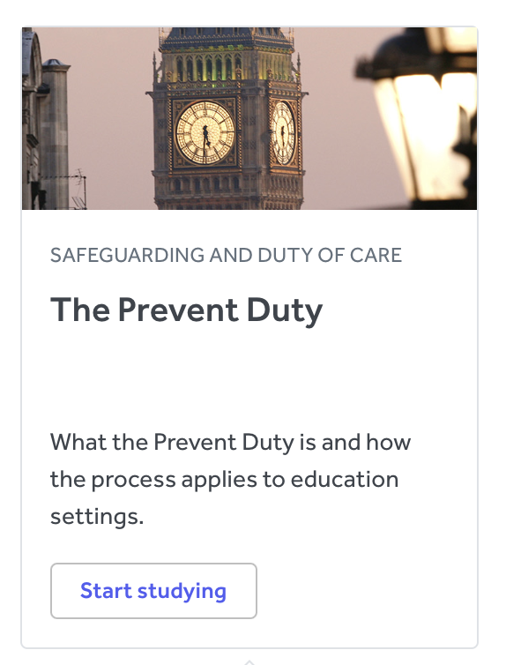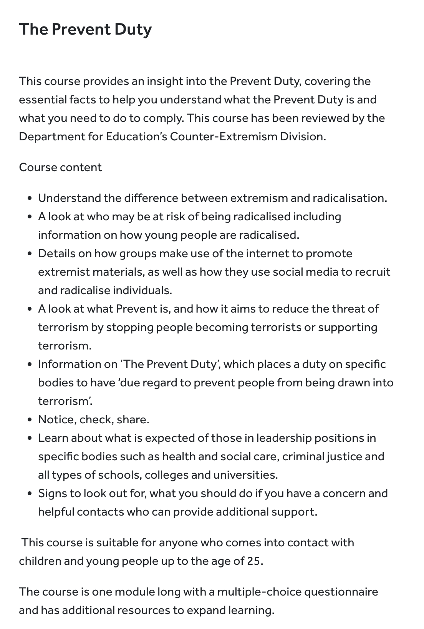

- Appropriate online filtering

Our school is committed to actively promoting the fundamental British values of democracy, the rule of law, individual liberty and mutual respect and tolerance of those with different faiths and beliefs. The pupils are encouraged to develop and demonstrate skills and attitudes that will allow them to participate fully in and contribute positively to life in modern Britain.

There is a current threat from terrorism in the UK and this can include the exploitation of vulnerable young people, aiming to involve them in terrorism or to be active in supporting terrorism.
Our school seeks to protect children and young people against the messages of all violent extremism including but not restricted to those linked to Islamist Ideology, Far Right / Neo Nazi / White Supremacist ideology etc. Concerns should be referred to the Designated Safeguarding Lead who has local contact details for the Prevent Engagement Team (Police) and Channel referrals. They will also consider whether circumstances require Police to be contacted urgently.

APPENDIX 5

Radicalisation and Extremism Risk Assessment- see Excel Risk assessment 2026

Meadow View Farm School

 |  |  | Yes/No | Evidence
Does the school have a policy? |  |  | Yes | Appendix 4 of Safeguarding Policy
Does the school work with outside  agencies on radicalisation and extremism e.g. Channel? |  |  | Yes
Have staff received appropriate training? |  |  | Yes | As per annual safeguarding training. Educare Prevent Training on induction or refreshed at least every 3 years (see staff training matrix)
Has the school got a trained Prevent  lead? |  |  | Yes | DSL/Head Teacher
Do staff know who to discuss concerns with? (DSL) |  |  | Yes | All staff have received Safeguarding and Prevent training (on induction, annually and at least every 3 years (Educare training))
Is suitable filtering of the internet in place? |  |  | Yes | SENSo, annually reviewed by Online Safety Lead (DSL)
Do children know who to talk to about their concerns? |  |  | Yes | As part of PSHE and Protective Behaviours
Are there opportunities for children to learn about radicalisation and extremism? |  |  | Yes | As appropriate, as part of curriculum: PSHE, History, and opportunities as and when they arise within society/news
Have any cases been reported? |  |  | No
Are individual pupils risk assessed? |  |  | Yes | Following the August 2024 Far Right Protests and unrest across the UK currently
What factors make the school community potentially vulnerable to being radicalised?  (e.g. EDL local base, extreme religious views promoted locally, tensions between local communities, promotion of radical websites by some pupils/parents) |  |  | (August 2024) There is currently an unrest across the UK in the form of Far Right protests. There is misinformation and disinformation being spread across media to influence people’s thoughts, feelings and actions.
Comment on the school’s community, locality and relevant history (see Dfe Risk assessment for more in-depth recording of risks and risk mitigation)

The children at MVFS have an EHCP. A significant proportion of the pupils have SEMH needs associated with attachment disorder, a significant proportion have communication and interaction needs (such as speech and language disorders or Autism). Lots of the children engage in online activity. They are vulnerable to being exposed to misinformation and disinformation through social media sights, as well as being groomed online.

Risk evaluation | Medium | Way Forward  Alert staff through training.  Alert parents through guidance  Staff closely monitor pupils interactions  Provide intervention for those children deemed as an increased risk (create risk assessments if needed and seek further advice and guidance)

Date completed: 03.08.2026
Signed: K Simpson

