

Whistleblowing Policy & Procedure

Updated: 27th April 2017
Updated: 12th April 2018
Reviewed: 27th May 2021
Updated: 2nd August 2021
Updated: August 2022
Updated: August 2024
Updated: August 2025
Updated: August 2026

Whistleblowing Policy and Procedure
Introduction
The school is committed to conducting its business with honesty and integrity, and expects all staff to maintain high standards in accordance with their contractual obligations and the school’s policies and procedures.
However, all organisations face the risk of things going wrong from time to time, or of unknowingly harbouring illegal or unethical conduct. A culture of openness and accountability is essential to prevent such situations occurring or to address them when they do occur.
This procedure is not a substitute for normal line management processes but an addition to them. Staff should always first consider using normal line management for raising concerns. This procedure is only for the purpose of raising concerns about wrongdoing and is not a substitute or alternative for existing procedures such as the Grievance, Disciplinary Procedures for staff or the complaints procedure.
This procedure should only be used where all other existing internal procedures are felt to be inappropriate or when a member of staff, for whatever reason, feels inhibited in going through the normal line management. As an example, therefore, if a member of staff has a personal grievance, then it must be raised through the grievance procedure; it would not be appropriate for it to be raised through this procedure. The existence of this procedure does not prevent staff from raising concerns through their trade union if they so wish. The procedure is therefore not a route through which employees can raise concerns about mismanagement which may arise from weak management rather than malpractice.
Meadow View Farm School is committed to maintaining an open and transparent safeguarding culture in which all staff feel confident to raise concerns about poor or unsafe practice without fear of disadvantage. Whistleblowing forms an essential part of the school's safeguarding arrangements.
Aims of Policy
- To encourage staff to report suspected wrongdoing as soon as possible, in the knowledge that their concerns will be taken seriously and investigated as appropriate, and that their confidentiality will be respected;
- To provide staff with guidance as to how to raise those concerns;
- To reassure staff that they should be able to raise genuine concerns in good faith without fear of reprisals, even if they turn out to be mistaken.
This policy takes account of the Whistleblowing Arrangements Code of Practice issued by the British Standards Institute and Public Concern at Work.
This policy does not form part of an employee’s contract of employment and is not intended to have contractual effect. It is provided for guidance to all members of staff at the School and the School reserves the right to amend its content at any time.
This Policy reflects the school’s current practices and applies to all individuals working at all levels of the organisation, including the Proprietary Body, Headteacher, members of the Senior Leadership Team, employees, consultants, contractors, trainees, part-time and fixed-term workers, casual and agency staff (collectively referred to as “Staff” in this policy) who are advised to familiarise themselves with its content.
Read this policy in conjunction with:
- MVFS Safeguarding Policy
- KCSIE (2026)
- Working together to safeguard children (2026)
- Online Safety Policy
- Guidance for safer working practice for those working with children and young people in education settings (2022)
- Intimate Care Policy
What is whistleblowing?
Whistleblowing is the disclosure of information which relates to suspected wrongdoing or dangers at work. This may include:
- criminal activity.
- child protection and/or safeguarding concerns; * See note at the end of this policy.
- miscarriages of justice.
- danger to health and safety.
- damage to the environment.
- failure to comply with any legal or professional obligation or regulatory requirements.
- financial fraud or mismanagement.
- negligence.
- breach of the school’s internal policies and procedures including its Code of Conduct.
- conduct likely to damage the school’s reputation.
- unauthorised disclosure of confidential information.
- low-level concerns (see policy as part of Safeguarding & Child Protection Policy). Concerns relating to staff conduct that meet the definition of a low-level concern should normally be managed through the school's Low-Level Concerns procedures. Where staff believe that these procedures have not been followed appropriately, or feel unable to raise the concern through those processes, this Whistleblowing Policy may be used.
- the deliberate concealment of any of the above matters.
Where a whistleblowing concern relates to the safety or welfare of a child, staff must not delay reporting the concern whilst considering this policy. Staff must continue to follow the Safeguarding and Child Protection Policy by reporting concerns immediately to the Designated Safeguarding Lead (DSL) or, where appropriate, directly to Children's Social Care or the police.
Whistleblowing arrangements complement, but do not replace, the school's safeguarding procedures.
A ‘whistleblower’ is a person who raises a genuine concern in good faith relating to any of the above. If you have any genuine concerns related to suspected wrongdoing or danger affecting any of the school’s activities (a whistleblowing concern) you should report it under this policy.
Staff are expected to exercise professional curiosity and raise concerns where something does not feel right, even where they do not have evidence that wrongdoing has occurred. It is better to raise a concern than risk a child remaining unsafe.
This policy should not be used for complaints relating to Staff’s own personal circumstances, such as the way you have been treated at work. In those cases, you should follow the Grievance Policy and Procedure.
If Staff are uncertain whether something is within the scope of this policy they should seek advice from the Headteacher and if the matter is in relation to an alleged wrongdoing by the Headteacher then the Staff should seek the advice of/whistle blow to the Proprietary Body.
Raising a whistleblowing concern
The school hopes that in many cases Staff will be able to raise any concerns with their Line Manager, speaking to them in person or putting the matter in writing if they prefer. They may be able to agree on a way of resolving a concern quickly and effectively. In some cases, they may refer the matter to the Proprietary Body.
Where the concern relates to safeguarding, the member of staff should also ensure that the Designated Safeguarding Lead is informed unless doing so would place a child or another person at greater risk or the concern relates directly to the DSL.
However, where the matter is more serious, or you feel that your Line Manager has not addressed your concern, or you prefer not to raise it with them for any reason, you should contact one of the following:
The Head Teacher
The Proprietary Body with responsibility for Whistleblowing matters
The Headteacher will arrange a meeting with the ‘whistleblower’ as soon as practicable to discuss their concern. They will record sufficient details to enable the matter to be thoroughly investigated. As a minimum the Headteacher will record the name of the employee but also indicate whether the individual wishes his or her identity to remain confidential, if possible and the nature of the concern. In some cases, it will not be possible to maintain confidentiality and the Headteacher should explain this to the employee. In such instances the employee will have the choice of either withdrawing or agreeing to his/her identity becoming known to enable the concern to be effectively dealt with.
Staff may bring a colleague or trade union representative to any meetings under this policy who must respect the confidentiality of the disclosure and any subsequent investigation.
The school will take notes and produce a written summary of the concern raised and provide the ‘whistleblower’ with a copy as soon as practicable after the meeting. The school will also aim to give the ‘whistleblower’ an indication of how it proposes to deal with the matter.
Confidentiality
The school hopes that Staff will feel able to voice whistleblowing concerns openly under this policy. However, if a member of staff wants to raise his or her concern confidentially, the school will endeavour to keep his or her identity unknown in so far as it is possible to do so when following this policy and procedure. If it is necessary for anyone investigating that member of staff’s concern to know the ‘whistleblower’s’ identity, the school will discuss this with the member of staff first.
The school does not encourage Staff to make disclosures anonymously. Proper investigation may be more difficult or impossible if the school cannot obtain further information. It is also more difficult to establish whether any allegations are credible and have been made in good faith. ‘Whistleblowers’ who are concerned about possible reprisals if their identity is revealed should come forward to one of the contacts listed above and appropriate measures can then be taken to preserve confidentiality.
If an individual misuses the policy and procedure e.g. by making malicious or repeated unsubstantiated complaints against colleagues, this could give rise to action under the School’s Disciplinary Procedure. If the Headteacher knows or has a suspicion that an employee comes into this category, then s/he will take advice from the Designated Proprietary Body who will help to determine what action should be taken.
If you are in any doubt, you can seek advice from NSPCC advice line:
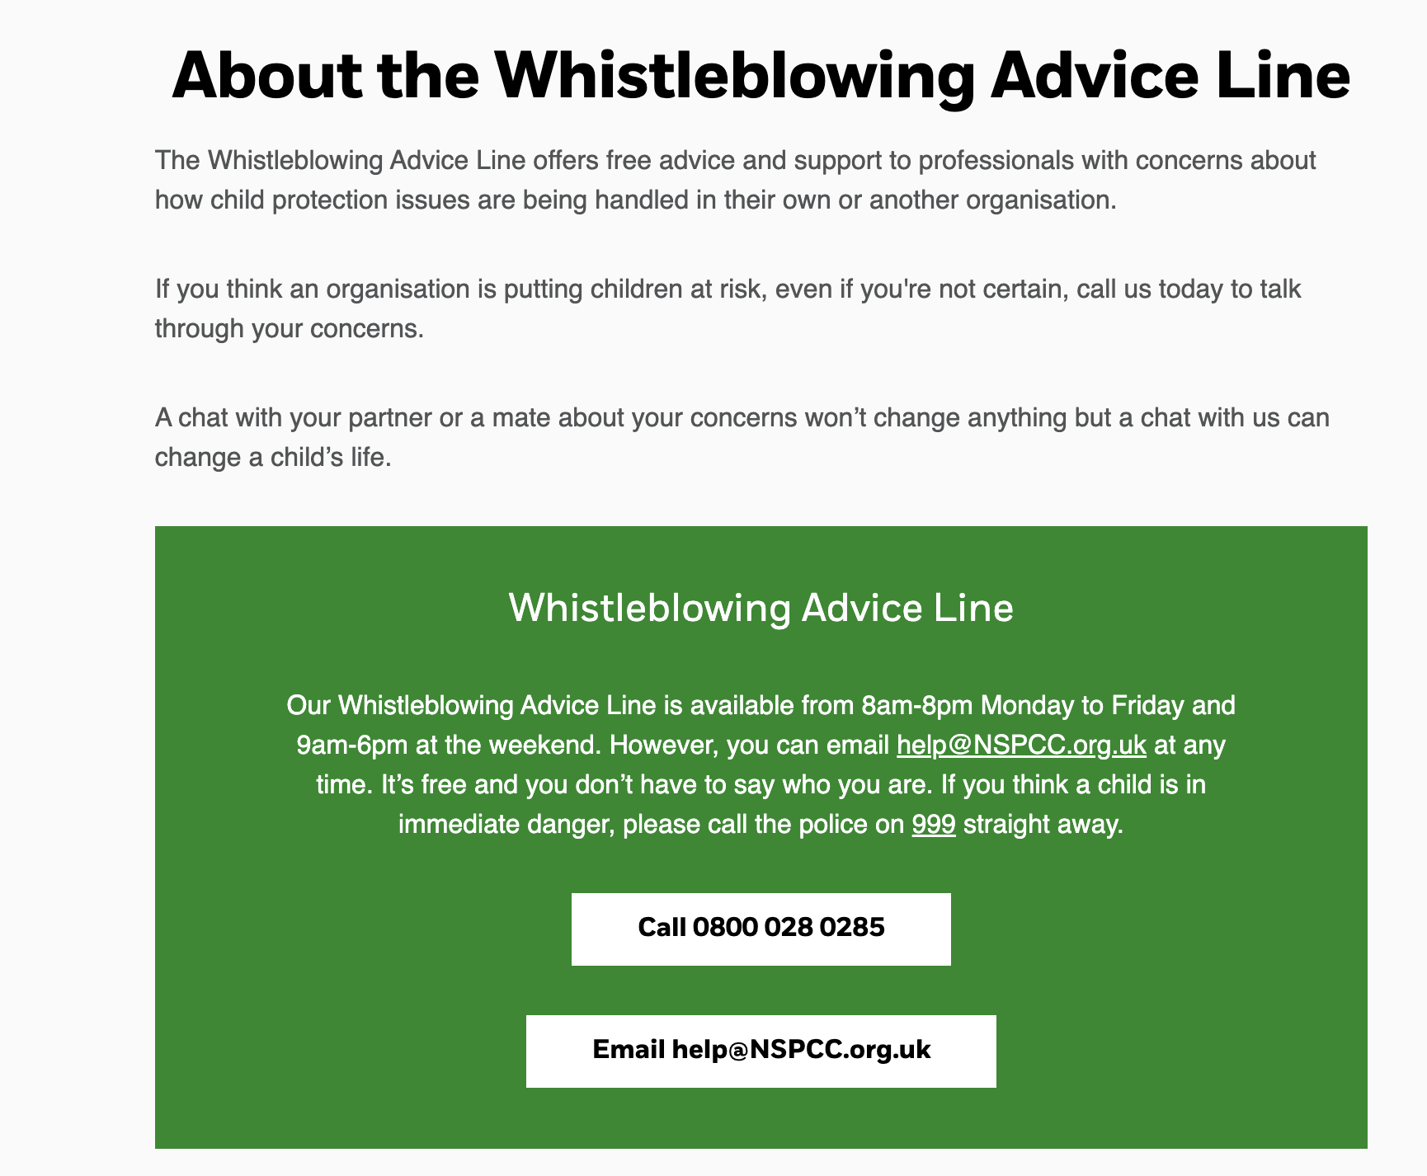

External disclosures
The aim of this policy is to provide an internal mechanism for reporting, investigating and remedying any wrongdoing in the workplace. In most cases Staff should not find it necessary to alert anyone externally.
The law recognises that in some circumstances it may be appropriate for Staff to report their concerns to an external body such as a regulator. It will very rarely if ever be appropriate to alert the media. We strongly encourage you to seek advice before reporting a concern to anyone external. The independent whistleblowing charity, Protect (formerly Public Concern at Work), operates a confidential helpline. They also have a list of prescribed regulators for reporting certain types of concern.
Staff may also seek independent advice from the NSPCC Whistleblowing Advice Line where concerns relate to the safeguarding or welfare of children.
Telephone: 0800 028 0285
Email: help@nspcc.org.uk
Whistleblowing concerns usually relate to the conduct of School Staff, but they may sometimes relate to the actions of a third party, such as a service provider. The law allows Staff to raise a concern in good faith with a third party, where the member of staff reasonably believes it relates mainly to their actions or something that is legally their responsibility. However, Staff are encouraged to report such concerns internally first. Staff should contact one of the other individuals set out above for guidance.
Investigation and outcome
Where a whistleblowing concern relates to safeguarding or an allegation against an adult working with children, the matter will be managed in accordance with Part Four of Keeping Children Safe in Education (2026), the school's Safeguarding Policy and local safeguarding partnership procedures.
Once a member of Staff has raised a concern, the School will carry out an initial assessment to determine the scope of any investigation. The School will inform the ‘whistleblower’ of the outcome of its assessment. The member of staff raising the concern may be required to attend additional meetings in order to provide further information.
In most cases a panel of three (ideally proprietary Body) will investigate any issue. In rare cases the School may appoint an investigator or team of investigators including Staff with relevant experience of investigations or specialist knowledge of the subject matter. The investigator(s) may make recommendations for change to enable the school to minimise the risk of future wrongdoing.
The school will aim to keep the member of staff informed of the progress of the investigation and its likely timescale. However, sometimes the need for confidentiality may prevent the school from giving specific details of the investigation or any disciplinary action taken as a result. The member of staff is required to treat any information about the investigation as strictly confidential.
If the School concludes that a ‘whistleblower’ has made false allegations maliciously, in bad faith or with a view to personal gain, the ‘whistleblower’ will be subject to disciplinary action under the school’s Disciplinary Policy and Procedure.
Whilst the school cannot always guarantee the outcome a particular member of staff is seeking, the school will try to deal with the concern fairly and in an appropriate way. If a member of staff is not happy with the way in which his or her concern has been handled, he or she can raise it with one of the other key contacts outlined above.
There are no rights of appeal against any decisions taken under this procedure. However, an employee or the Headteacher will have the right to refer any particular case to the Designated Proprietary Body for review.
Any member of staff raising a concern under the procedure will be kept informed of progress by the Headteacher, including, where appropriate, the final outcome. However, in certain circumstances, e.g. where disciplinary action under the School’s Disciplinary Procedure has resulted from the concern, it may not be appropriate to provide specific details due to the confidentiality and sensitivity of such matters.
Responsibilities of the ‘whistleblower’
The ‘whistleblower’ has a responsibility to follow all procedures as laid down in this policy correctly and in a timely manner. It is imperative that all aspects of a concern and any investigation they are aware of is kept in the strictest confidence. Failure to do this will compromise any outcomes of an investigation. Information should only be shared with the Head teacher or Proprietary Body.
Protection and support for ‘whistleblowers’
The school will take all reasonable steps to ensure that staff raising concerns in good faith are supported throughout the process and protected from victimisation or detriment.
It is understandable that ‘whistleblower’s are sometimes worried about possible repercussions. The School aims to encourage openness and will support Staff who raise genuine concerns in good faith under this policy, even if they turn out to be mistaken.
Staff must not suffer any detrimental treatment as a result of raising a concern in good faith. Detrimental treatment would include dismissal, disciplinary action, threats or other unfavourable treatment connected with raising a concern. If a member of staff believes that he or she has suffered any such treatment, he or she should inform the Headteacher immediately. If the matter is not remedied the member of staff should raise it formally using the School’s Grievance Policy and Procedure.
Staff must not threaten or retaliate against ‘whistleblowers’ in any way. Anyone involved in such conduct will be subject to disciplinary action.
All Staff are responsible for the success of this policy and should ensure that they use it to disclose any suspected danger or wrongdoing. Staff are invited to comment on this policy and suggest ways in which it might be improved. Comments, suggestions and queries should be addressed to the Headteacher in the first instance.
Safeguarding
If a member of staff believes that safeguarding concerns are not being responded to appropriately, or that there is a failure to protect children from harm, they must raise their concerns immediately through this policy.
Where concerns relate to the Headteacher they should be raised directly with the Proprietary Body.
Where concerns relate to the Designated Safeguarding Lead they should be raised with the Headteacher or Proprietary Body.
Nothing within this policy prevents staff from making a referral directly to Children's Social Care, the Police, the Local Authority Designated Officer (LADO), or seeking advice from the NSPCC Whistleblowing Advice Line where appropriate.

Appendix 1
Don’t think ‘what if I’m wrong?’ – think ‘what if I’m right?’
Reasons for whistleblowing:
- Each individual has a responsibility for raising concerns about unacceptable practice or behaviour.
- To prevent the problem worsening or widening.
- To protect or reduce risks to others.
- To prevent becoming implicated yourself.
What stops people from whistle blowing:
- Starting a chain of events which spirals.
- Disrupting the work or project.
- Fear of getting it wrong.
- Fear of repercussions or damaging careers.
- Fear of not being believed.
How to raise a concern:
- You should voice your concerns, suspicions or uneasiness as soon as you feel you can. The earlier a concern is expressed the easier and sooner action can be taken.
- Try to pinpoint exactly what practice is concerning you and why.
- Approach your immediate manager, Head Teacher, or the Designated Safeguarding Lead (in the Head Teachers absence), inappropriate sharing of information or concerns elsewhere could negatively impact on any investigation.
- If your concern is about your immediate manager/Head Teacher, or you feel you need to take it to someone outside the school contact The Local Authority Designated Officer.
- Make sure you get a satisfactory response – don’t let matters rest. If you believe appropriate action has not been taken, continue to escalate your concerns until you are satisfied they have been properly considered. Never assume somebody else will raise the concern.
- You should then put your concerns in writing, outlining the background and history, giving names, dates and places where you can.
- A member of staff is not expected to prove the truth of an allegation but will need to demonstrate sufficient grounds for the concern.

What happens next?
You should be given information on the nature and progress of any enquiries. Your employer has a responsibility to protect you from harassment or victimisation.
No action will be taken against you if the concern proves to be unfounded and was raised in good faith.
Allegations made frivolously, maliciously or for personal gain will be seen in a different light and disciplinary action may be taken.
Self reporting
There may be occasions where a member of staff has a personal difficulty, or perhaps a physical or mental health problem, which they know to be impinging on their professional competence. Staff have a responsibility to discuss such a situation with their line manager so professional and personal support can be offered to the member of staff concerned. Whilst such reporting will remain confidential in most situations, this cannot be guaranteed where personal difficulties raise concerns about the welfare or safety of children.
Further advice and support
It is recognised that whistle blowing can be difficult and stressful. Advice and support is available from your line manager, HR department and/or your professional trade union.

Appendix 2

Safeguarding Whistleblowing Flowchart

Concern identified
↓
Speak to Line Manager
(where appropriate)
↓
Safeguarding concern?
↓
YES
↓
Inform DSL immediately
↓
Concern about DSL?
↓
Inform Headteacher
↓
Concern about Headteacher?
↓
Inform Proprietary Body
↓
Still concerned?
↓
Contact:
• Children's Social Care
• Police
• LADO
• NSPCC Whistleblowing Advice Line
↓
Record outcome

