
Newsletter
Autumn Term 2024

Parent Workshop/Meetings
Preparing for Christmas Workshop
Autumn Term Date: Friday 15th November 2024 at 10:30 – 11:30 invites have been sent out via email.
If you have any requests for parent workshops, please email me at ksimpson@mvfs.org.uk

Staffing
We’re sad to be saying goodbye to some highly valued members of staff, whilst welcoming some new members to the team.

Jayde, who started with us as a Teaching Assistant and is currently working as our receptionist is leaving us over the half term break. She has been successful in gaining a position, which we think she will be amazing at. I’d like to thank her for all her hard work, flexibility and commitment to MVFS. She is really going to be missed. Sian will be replacing Jayde and has already started some transition time with us.

There will be changes to staffing in the Autumn Term, after we have successfully recruited two new teachers. Amy will be starting after the October break to work with the children in Class 4, as Meg is pregnant and due to go on maternity leave soon. Ryan (another one) will join the team to teach in Class 5. He will join us after Christmas. This sadly means that Jess M will be leaving us. Jess has been a big part of the MVFS family for such a long time, starting as a member of support staff and qualifying as a teacher with us; she is really going to be missed. Jess leaves us, after Christmas, to spend more time with her young family, but has promised to lend a hand in the future when called upon, so we might not have seen the last of her!

MVFS would like to say a big thank you to Leicestershire Constabulary for visiting and talking to the children about their role in the community.

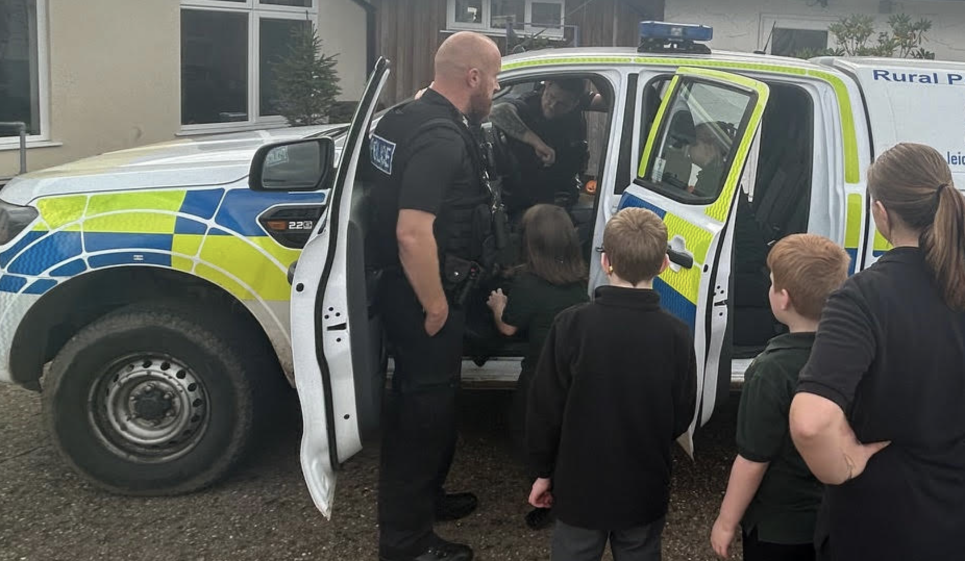

Dear Parents/Carers,
What a lovely start it has been to the new term. It has been so lovely welcoming all of the children back, after the summer break, and seeing the new starters settle into their new classes.
Have a lovely break all and I’ll look forward to seeing you all on Monday 4th November.
Katie
Forest School
John has settled into his role and is delivering Forest School sessions to each class.
As we head into the winter months, please continue to send in appropriate clothing.
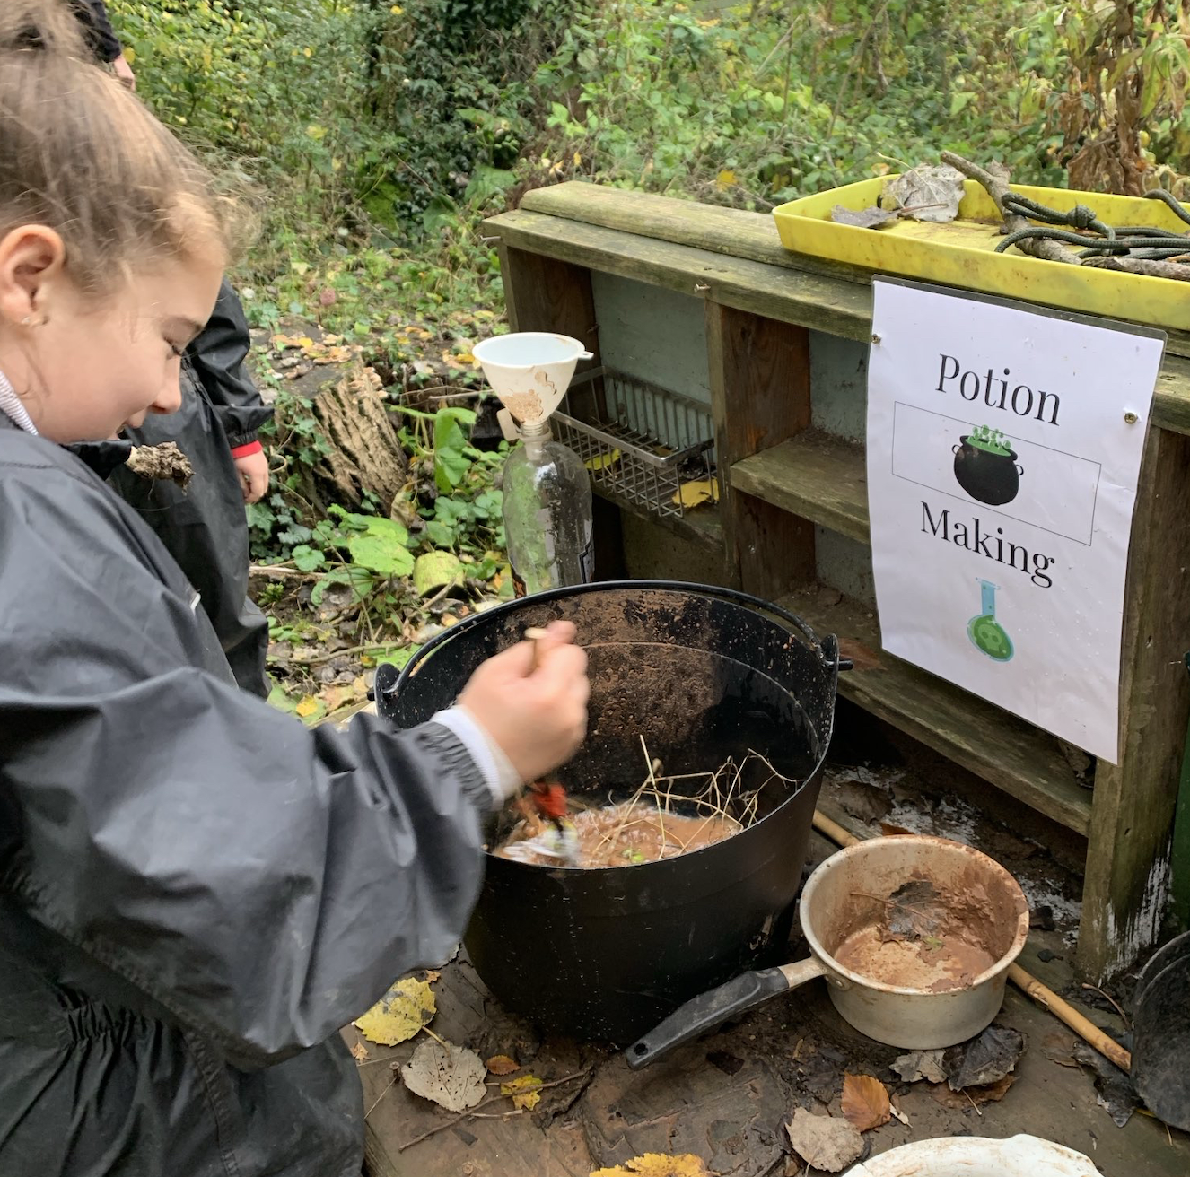
Since coming back from the summer holidays, the children have been taking part in a variety of activities off-site.

Next half term:
Offsite Activities for Autumn 2
Class 1: Sport in Desford with Ben
Class 2: Horse Riding (Friday)
Class 3: Sport in Desford
Class 4: Swimming (Wednesday)
Class 5: Swimming (Thursday)
Important Dates
4th November 2024 - Start of Autumn Term 2
Friday 15th November 2024- Preparing for Christmas Workshop
20th December 2024 – End of Autumn Term 2
Monday 6th January 2025- First day of Spring 1

